Financial Control System (FCS)
Accounts Payable Project.
User 's Manual
Filing Reference : | ISS/FCS2/TU.1/1
Document Title : | User's Manual
Version : | 1.0
Prepared By : | Low Siew Heng
Approved By :
 | Howard Russon | Date
 | Project Manager
Authorised By :
 | Mike Fenton | Date
 | Project Director
 | Lian Wee Li | Date
 | Admin. Manager

©1993 ISS.  The information contained in this document is the property of ISS. The contents must not be reproduced, wholly or in part, for purposes other than for which it has been supplied, without the prior permission of ISS, or, if it has been furnished under contract to another party, as expressly authorised under that contract. ISS shall not be liable for any errors or omissions. | ISS

Document Reference : ISS/FCS2/TU.1/1
Version | Date | Author | Authorised by | Date
1.0 | 08/11/26 | Low Siew Heng
Financial Control System (FCS)
Accounts Payable Project.
User's Manual
Distribution :
Name | Department | Organisation
Mike Fenton
Howard Russon
Lim Swee Cheang
Lian Wee Li (4 copies)
Low Siew Heng
Frank Jenkins

Table of Contents.
1. INTRODUCTION. 1
1.1 Purpose. 1
1.2 Audience. 1
1.3 Organisation. 1
1.4 References. 2
2. USER INSTRUCTIONS. 2
2.1 Getting Started. 2
2.2 Maintaining Supplier records. 3
2.3 Maintaining Cost Centre Records. 5
2.4 Maintaining Vote Category Records. 6
2.5 Maintaining Currency Records. 8
2.6 Maintaining Professional Societies. 9
2.7 Preparing Purchase Orders. 10
2.8 Receiving Invoices. 13
2.9 Updating Credit Notes. 20
2.10 Updating Debit Notes. 21
2.11 Cancellation of P/O Items. 22
2.12 Preparing Claims /Payments Records. 24
2.13 Updating Staff Travelling Records. 29
2.14 Recoupment of Petty Cash. 33
2.15 NUS Payment Update. 33
2.16 Preparing Journal Adjustment. 36
2.17 Funds Transfer. 39
2.18 Preparing Budget Accounts For A Financial Year. 41
2.19 Maintaining Cost Centres of Staff Record. 44
2.20 Producing Standard Reports. 44
2.21 Utility. 51
3. ERROR MESSAGES & PROBLEM SOLVING. 53
3.1 Duplicate Records Messages. 53

Table of Contents.
3.2 Invalid Date Error Messages. 54
3.3 Insufficient funds available. 54
3.4 Total Committed Amount Error. 54
3.5 Total Amount of Funds Cancelled Error. 54
3.6 Petty Cash Balance Error. 54
3.7 Error Message for NUS Cash Payment. 55
3.8 Funds Transfer Error Messages. 55
3.9 Zero Commitment. 55
3.10 Invalid Financial Year and Month. 55
3.11 Invalid numeric data. 56
3.12 Invalid Currency Exchange Rate. 56
3.13 Invalid S$ Amount. 56
3.14 Applications Execution Error Messages. 56
Appendix A SAMPLES OF REPORTS.

1. INTRODUCTION.
The Institute of Systems Science (ISS) requires the development of a Financial Control System (FCS). This will involve the computerisation of the two major functions of the current manual system:
1. Invoice/Accounts Receivable; and
2. Accounts Payable.
The development is required to be undertaken in two stages. The first stage, to develop the Invoice/Accounts Receivable module, has been completed. This project is required to undertake Stage 2 of the development, to develop the Accounts Payable module of the system. In addition, the project is required to undertake the enhancement of the existing module (Invoice / Accounts Receivable) to meet the new requirements.

1.1 Purpose.
The purpose of this document is to provide the system instructions that will enable the users to use the Accounts Payable module of the FCS.

1.2 Audience.
The intended readers of this manual are the users, who are responsible for using this system. This document should provide all the necessary instructions.

1.3 Organisation.
The FCS Accounts Payable is a MS Windows application. An introduction to the use of Windows has been described in the FCS Invoice/Accounts Receivable User's manual (Please refer to Section 2 in the FCS Invoice/Accounts Receivable User's manual).
The instruction of how to use the following functions of FCS Accounts Payable are described in Section 2 :
• maintaining the various data base of suppliers; cost centres, vote categories, professional societies and exchange rate;
• creating purchase orders;
• processing received invoices from supplies;
• updating credit and debit notes;
• cancelling a P/O item;
• preparing claims / expenses records;
• updating NUS cash payment;
• preparing journal adjustment records;
• transferring funds;
• preparing budget accounts for a financial year;
• maintaining cost centres of staff records;
• producing management reports.
Finally, Section 3 explains how to solve the problem when an error message is displayed.

1.4 References.
To fully understand the background to this project, the reader should also be familiarized with:
1. FCS Accounts Payable Project Plan, reference ISS/FCS2/MP.1/1, version 1.0, dated 9 July 1993.
2. FCS Accounts Payable Quality Plan, reference ISS/FCS2/MQ.1/1, version 1.0, dated 3 March 1994.
3. FCS Accounts Payable User Requirement Specification, reference ISS/FCS2/TS.1/1, version 1.0, dated 14 October 1993.
4. FCS Accounts Payable System Specification, reference ISS/FCS2/TS.2/1, version 1.0, dated 4 May 1994.

2. USER INSTRUCTIONS.
FCS Accounts Payable (FCS A/P) module is designed to run under Windows. This section describes the procedure of executing the FCS Accounts Payable program and it presumes that the users know the basics of using Windows.

2.1 Getting Started.
1. Double-click Applications group icon from the Program Manager window.
2. The Applications group window (Figure 2.1.1) appears. Double-click FCS A/P icon to run the FCS A/P program.
Figure 2.1.1: Application window
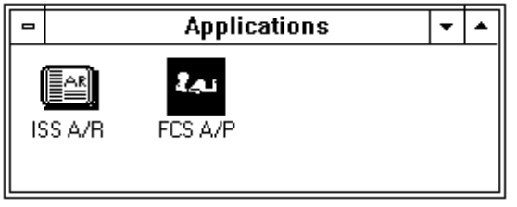
3. The FCS A/P application window is displayed and followed by a Sybase user login dialog box (Figure 2.1.2). Type in your Sybase user id in the user id text box as shown in Sybase user login dialog box.
Figure 2.1.2: FCS A/P application window & user login dialog box
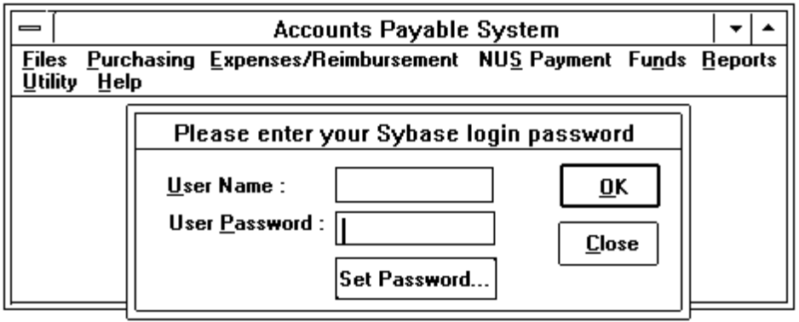
4. Press the Tab key or use mouse to move the mouse pointer at the password text box. Type in your password.
5. An error message 'Login failed ! Please retry.' will be displayed if you type in an invalid user id or password. You have to choose the 'Open Database' command from the File menu to enter the user id and password again in order to log into the Sybase server.
6. You should inform the staff-in-charge, if you see the error message which is shown in Figure 2.1.3.
Figure 2.1.3: Error Message for SQL Server Connection timed out

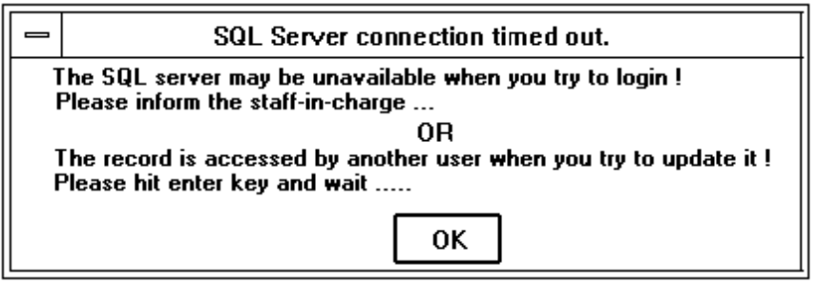

2.2 Maintaining Supplier records.
Figure 2.2.1: File Menu Command
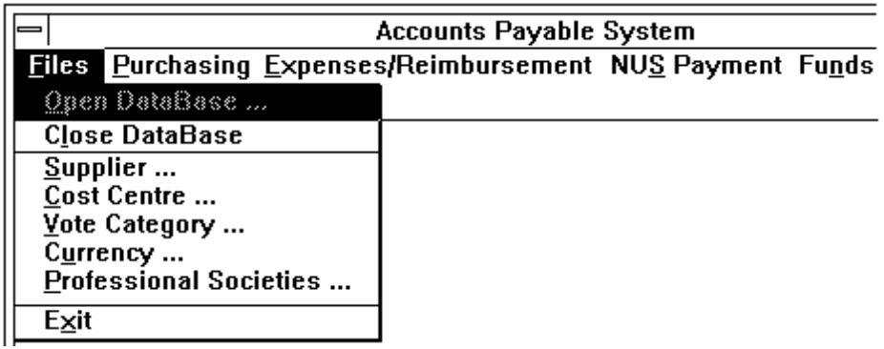
From the File menu, (Figure 2.2.1) choose Supplier command (or press ALT F, S). The following Supplier dialog box (Figure 2.2.2) is displayed and you can select any one of the functions (View, Edit, Add, Delete and Exit) shown at the top of the dialog box.
Figure 2.2.2: Supplier Dialog Box
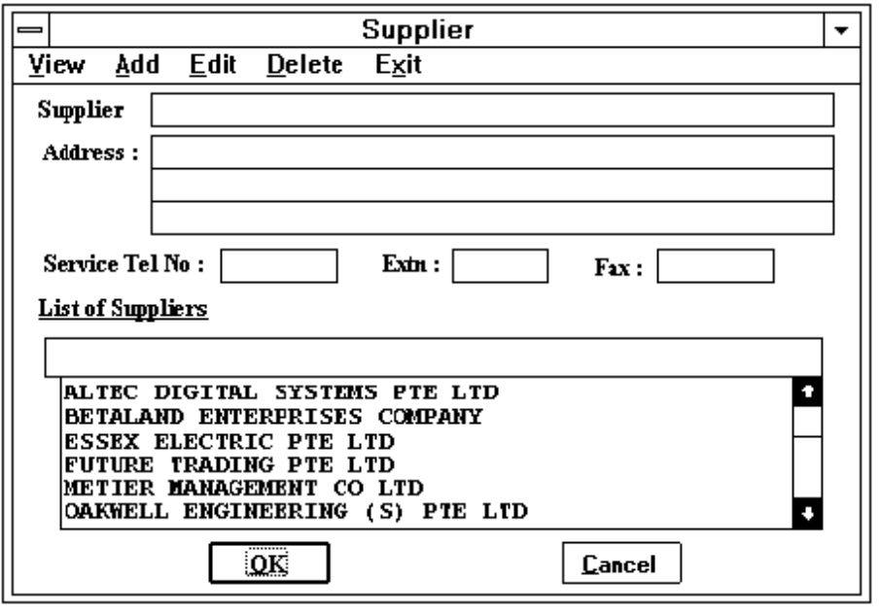

2.2.1 Create new Supplier records.
1. Select the Add function from the Supplier Dialog Box to create new supplier record.
2. Use the Tab key to move the cursor to the next text box after finishing each entry.
3. The supplier's name and address are always converted to upper case characters.
4. The supplier record will not be created if you choose the 'Cancel' button.
Figure 2.2.3: Message for the record already exists
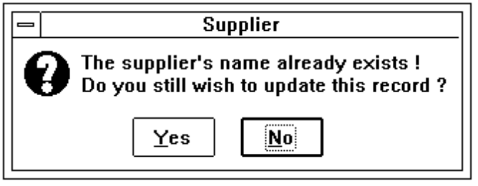
5. The supplier record will be created when you press the OK button. A message box (Figure 2.2.3) will be displayed to warn the user if the entered supplier has already been created previously.

2.2.2 View, Edit or Delete Supplier records.
1. Select the View, Edit or Delete function from the Supplier Dialog Box.
2. From the Supplier Combo List box, click on the supplier name which you want to view, edit or delete. The detailed information of the selected supplier will be displayed.
3. The user can modify all the entries when the selected function is Edit.
4. For Delete function, the confirmation message box (Figure 2.2.4) is always displayed for the users to confirm whether the record should be deleted.
• Yes deletes the record.
• No does not delete the record.
Figure 2.2.4: Confirmation Dialog Box
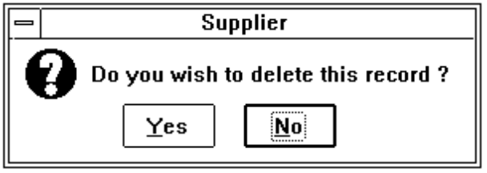

2.3 Maintaining Cost Centre Records.
From the File menu (Figure 2.2.1), choose Cost Centre command (or press ALT F, C). The Cost Centre dialog box (Figure 2.3.1) is displayed and user can select any one of the functions (View, Edit, Add, Delete and Exit) shown at the top of the dialog box (Figure 2.3.1).
Figure 2.3.1: Cost Centre Dialog Box
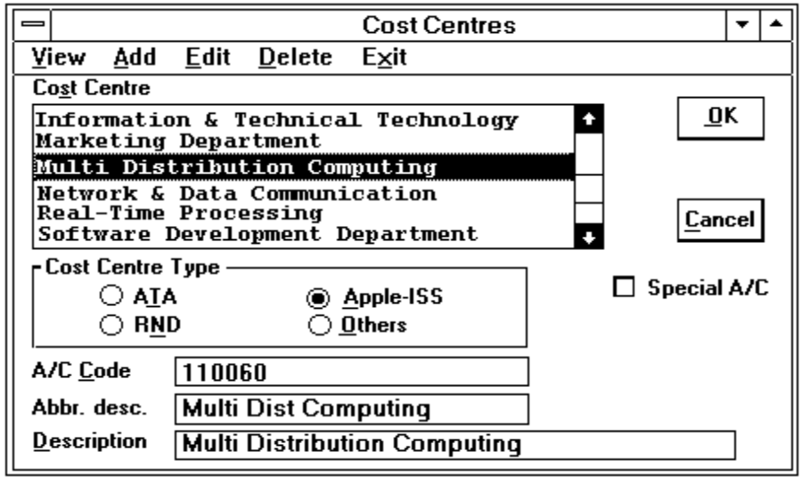

2.3.1 Create Cost Centre Records.
1. Select the Add function from the cost centre dialog box to create new cost centre.
2. Choose a radio button from the Cost Centre Type group box. By default, the ATA button is highlighted.
3. Use the Tab key to move the cursor to the next entry after finishing each entry.
4. The Special A/C check box is used to indicate whether the vote has the same vote number as cost centre A/C code. The user has to mark the check box (with a 'x' in the box) if it is.
5. The item Abbr. desc is used to store the the abbreviation description of the cost centre. It will be used to print the description of cost centre in some reports due to the space constrains.
6. The cost centre record will not be created if Cancel button is chosen.
7. The cost centre record will be created when you press the OK button. If the record was created previously, an error message 'This record already exists !' will be displayed to warn the user .

2.3.2 View, Edit or Delete Cost Centre Records.
1. Select View, Edit or Delete function from the cost centre dialog box.
2. Select a cost centre from the Cost Centre list box shown in Figure 2.3.1. The detailed information of the selected cost centre will be displayed.
3. For Edit Function, the A/C code cannot be modified for the sake of security.
4. For Delete function, a confirmation message box (Figure 2.2.4) is always displayed for the user to confirm whether the record should be deleted.
• Yes deletes the record.
• No does not delete the record.

2.4 Maintaining Vote Category Records.
From the File menu (Figure 2.2.1), choose the Vote Category command (or press ALT F, V). The Vote Category dialog box (Figure 2.4.1) is displayed and user can select any one of the functions (View, Edit, Add, Delete and Exit) shown at the top of the dialog box.
Figure 2.4.1: Vote Category Dialog Box
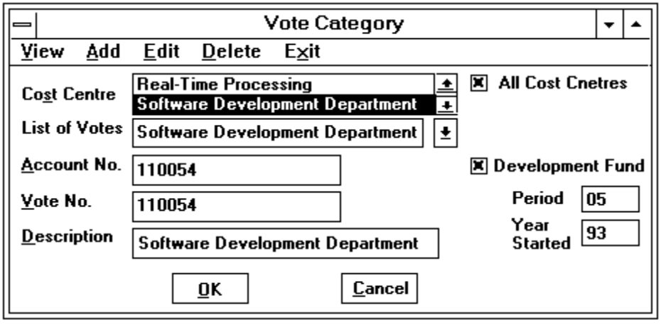

2.4.1 Create Vote Category Records.
1. Select Add function of the vote category dialog box to add new vote record.
2. The check box 'All Cost Centres' used to indicate a new vote is created for all cost centres if it is checked (marked with a 'x' in it). Otherwise, user has to select a list of cost centres from the cost centre list box.
3. If the check box 'Development Fund' is checked (marked with a 'x' in it), user has to enter the following entries:
• Period Number of years of the fund to be budgeted for
• Year Started The year to be started
4. Use the Tab key to shift the cursor to the next field entry and enter the vote number and vote description.
5. Choose one of the following buttons to confirm the entries.
• OK To accept the vote entries
• Cancel To cancel the vote entries

2.4.2 View, Edit or Delete Vote Category Records.
1. Select View, Edit or Delete function from the vote category dialog box.
2. Select the cost centre from the cost centre list box and a list of vote records of the specified cost centre will be displayed in the list of votes list box for the user to select.
3. The detail of the selected vote record will be displayed.
4. The user can modify all the entries except vote number when the selected function is Edit. To modify a vote number, the user has to delete that vote record and re-create it with a new code.
5. For Delete function, a confirmation message box (Figure 2.2.4) is always displayed for the user to confirm whether the record should be deleted.
• Yes deletes the record.
• No does not delete the record.

2.5 Maintaining Currency Records.
From the File menu (Figure 2.2.1), choose the Currency command (or press ALT F, U). The following dialog box (Figure 2.5.1) is displayed.
Figure 2.5.1: Currency Dialog Box
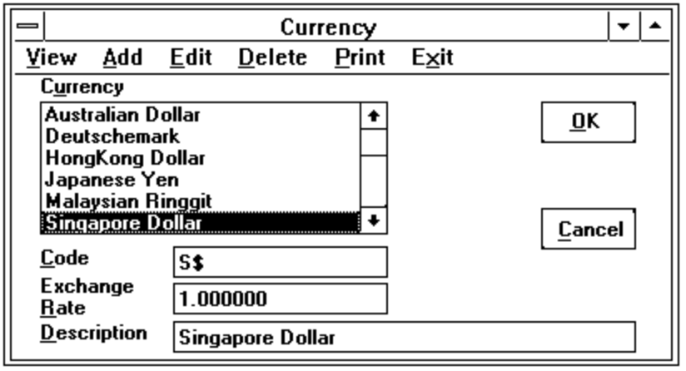

2.5.1 Create Currency Records.
1. Select Add function from the dialog box (Figure 2.5.1) to enter the detailed information of a new currency.
2. The maximum length of the currency code is 3 characters long, whereas the length of the currency description is 20 characters long.
3. The exchange rate is accepted up to 6 decimal places.
4. Choose one of the following buttons to confirm the entries.
• OK creates the record
• Cancel cancels the record and user can choose another function from the dialog box.

2.5.2 View, Edit or Delete Currency Records.
1. Selects View, Edit, or Delete function from the dialog box.
2. Select a currency from the Currency list box. The detailed information of the selected currency will be displayed.
3. For Edit function, the currency code cannot be modified for the sake of security.
4. A confirmation message box (Figure 2.2.4) will be displayed for the user to confirm again whether the record should be deleted for Delete function.
• Yes deletes the record.
• No does not delete the record.

2.5.3 Print the Currency Report.
1. Selects Print function from the dialog box. The following dialog box (Figure 2.5.2) is displayed for user to enter the remark.
Figure 2.5.2: Remark Input dialog box
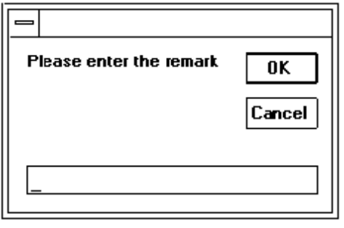
2. The report will be printed on the HP Laser printer. For the sample of the report, please refer to Appendix A/15.

2.6 Maintaining Professional Societies.
From the File menu (Figure 2.2.1), choose Professional Societies command (or press ALT F, P). The following dialog box (Figure 2.6.1) is displayed.
Figure 2.6.1: Professional Societies Dialog Box
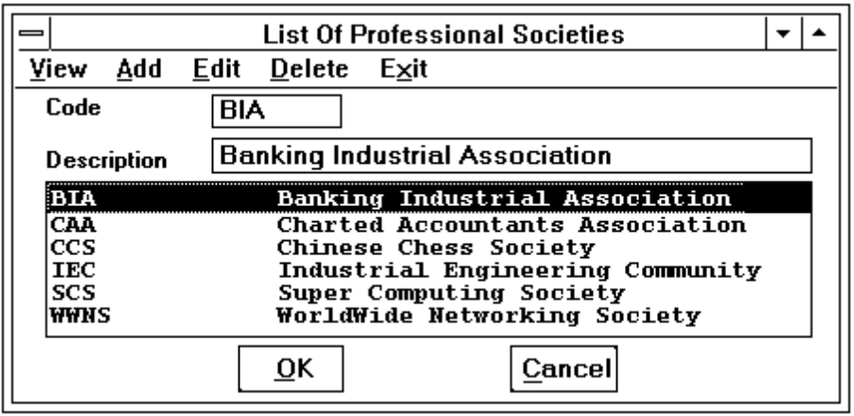

2.6.1 Create Professional Society Records.
1. Select Add function from the professional societies dialog box.
2. The user has to enter the society code and description.
3. The maximum length of the society code and description is 10 and 40 characters long respectively.
4. Choose one of the following buttons to confirm the entries.
• OK accepts the entries and record will be created.
• Cancel cancels the entries and record will not be created.

2.6.2 View, Edit or Delete Professional Society Records.
1. Select View, Edit or Delete function from the dialog box (Figure 2.6.1).
2. Select a professional society from the Society list box.
3. For Edit function, please note that the professional society code cannot be modified. If the code is created incorrectly, the user must delete the record and then create the record again.
4. For Delete function, a confirmation message box (Figure 2.2.4) is always displayed for user to confirm whether the record should be deleted.
• Yes deletes the record.
• No does not delete the record.

2.7 Preparing Purchase Orders.
Select Purchase Orders command (or press ALT P, P) from the Purchasing menu (Figure 2.7.1). The purchase order dialog box (Figure 2.7.2) is displayed.
Figure 2.7.1: Purchasing Menu Command
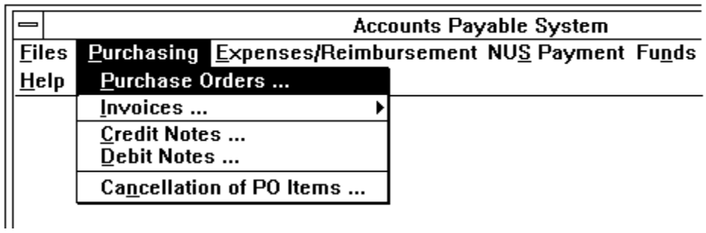

2.7.1 Create Purchase Orders.
1. Select Add function from the purchase orders dialog box (Figure 2.7.2) to enter the purchase order.
2. Select a supplier from the Supplier drop-down list box. The address of the supplier will be displayed. Dates can be edited if necessary.
Figure 2.7.2: Purchase Order Dialog Box
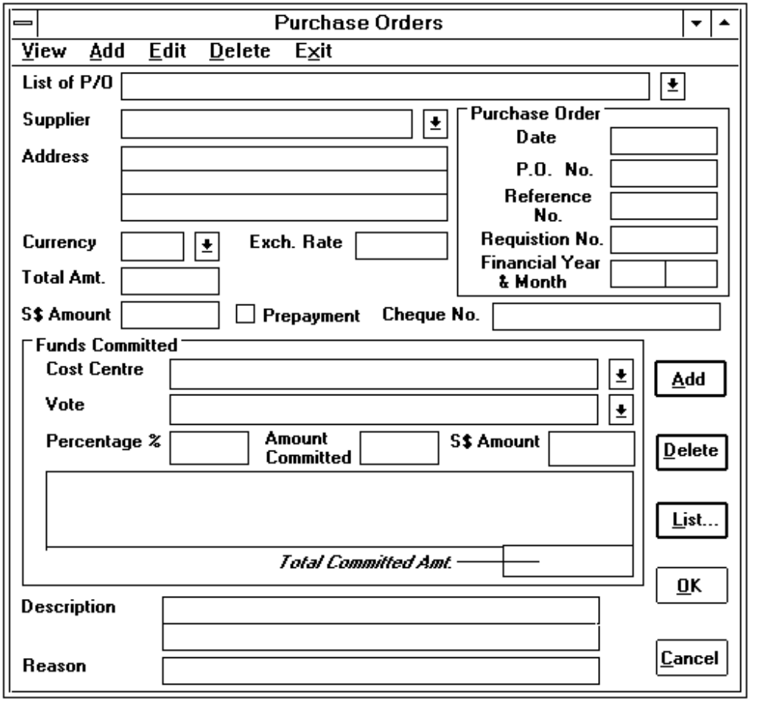
3. Use the Tab key or Enter key to move the cursor to the next text box after finishing each entry.
4. Enter the P/O date. By default, it is the current system date. Please note that the financial year and month are always the same as the year and month of the P/O date.
5. Enter the P/O No. and the Requisition No. By default, the reference number is the same as P/O No.
6. User can select a currency from the Currency drop-down list box if it is not S$. Once the currency is selected, the exchange rate will be displayed. The exchange rate can be overridden if there is a difference.
7. The entry 'S$ Amount' is used to enter the S$ equivalent amount of the P/O amount. Normally, it is computed by the system based on the given exchange rate and the P/O amount. It can be overridden by the user.
8. The check box 'Prepayment' is used to indicate whether the payment for this P/O has been made. If it is checked (marked with a 'x'), user is required to enter the cheque number in the 'Cheque No.' text box. By default, this box is unchecked (no prepayment is made).
9. For the funds commitment, user has to select a cost centre from the cost centre drop-down list box. A list of votes of the selected cost centre will be displayed in the 'list of votes' list box for user to select.
10. Once user has selected the vote, the percentage, amount committed and the S$ committed amount are computed by the system. All these entries can be overridden by the user.
11. Choose the Add button to confirm that the selected vote and the amount committed are accepted and it is displayed in the funds commitment list box. Repeat procedure 9, 10 and 11 until the total committed amount is equal to the P/O amount.
12. User can choose Delete button to delete a selected funds commitment from the funds commitment list box.
13. The description is for general purpose remarks. There are two lines with 40 characters each.
14. Choose one of the following buttons to confirm the entries.
• OK accepts the entries and record will be created.
• Cancel cancels the entries and record will not be created.

2.7.2 View, Edit or Delete Purchase Orders.
1. Select View, Edit or Delete function from the purchase orders dialog box (Figure 2.7.2).
2. Choose the List button before selecting a P/O from the 'List of P/O' drop-down list box. The following dialog box (Figure 2.7.3) is displayed when user chooses the List button.
3. Enter the range of the P/O No. or Supplier (depend on the selection of type of Sort Order By) and the financial year in the above dialog box (Figure 2.7.3). By default, the financial year is the current year and the sequence is ordered by P/O No.
Figure 2.7.3: P/O Selection dialog box
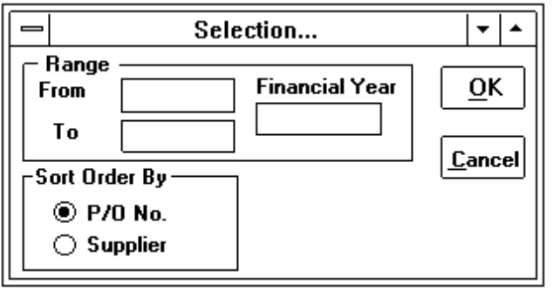
4. After pressing the OK button, list of P/O records will be displayed in the 'List of P/O' drop-down list box (Figure 2.7.2) for user to select.
5. For Edit function, please note that the P/O number cannot be modified. If it is created incorrectly, the user must delete the record and then create the record again.
6. For Delete function, user has to type the reason of deletion and a confirmation message box (Figure 2.2.4) is always displayed for the user to confirm whether the record should be deleted. Please note that only authorised persons can delete the purchase order. Otherwise, an error message will be displayed to warn the user.

2.8 Receiving Invoices.
There are three possible cases for entering the invoices received from the suppliers. Select Invoice command from the Purchasing menu and then a pull down menu (Figure 2.8.1) is displayed. The user can choose options for entering invoices from the pull down menu.
Figure 2.8.1: Invoice Menu Command
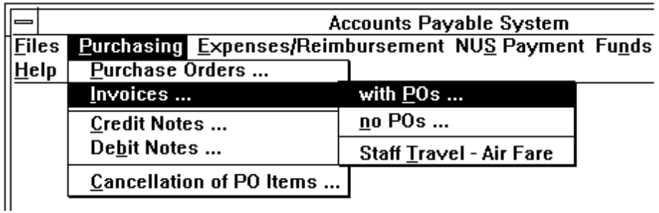

2.8.1 Create Invoices with P/Os.
1. Choose with POs command from the pull down menu of the Invoices command. The following dialog box (Figure 2.8.2) is displayed. Select Add function from the invoice dialog box
2. User can enter the P/O in the 'Purchase Order No.' text box or select a P/O from the 'List of P/Os' drop-down list box. The detailed information of the selected P/O will be appeared.
Note : To get a list of the specified P/Os displayed in the 'List of P/Os' drop-down list box, user has to choose the List button. For more information about List button, please refer to Section 2.7.2 (para 2 to 4).
3. The 'Final Invoice' check box is used to indicate whether this invoice is the final invoice of the selected P/O. By default, it is preset as final invoice (marked with a 'x' in the box).
4. By default the invoice amount is the net balance amount of the P/O. However, user can override this amount.
Figure 2.8.2: Invoice with P/O Dialog Box
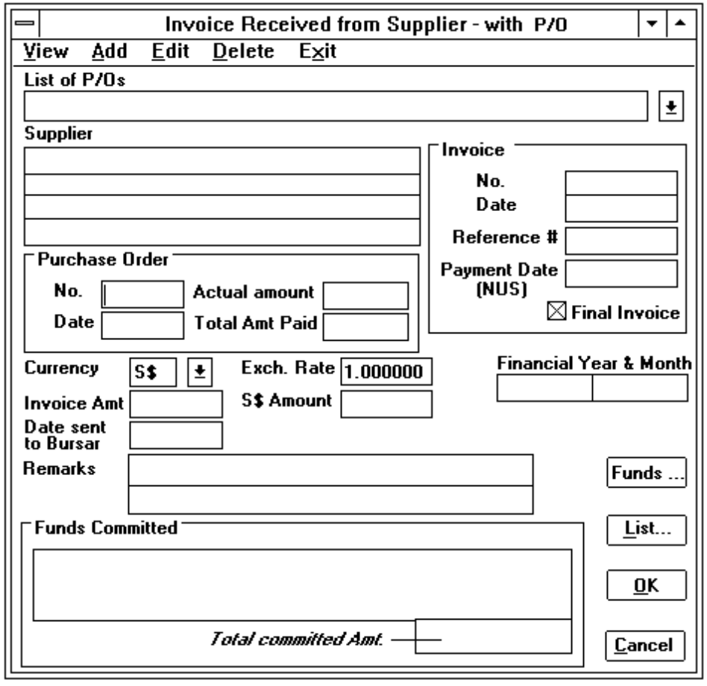
5. Select a currency from the Currency drop-down list box. By default, it is the same as the currency shown in the P/O. The exchange rate that is used to compute the equivalent S$ Amount, is displayed after a currency code is selected. The user can amend the exchange rate if it is necessary.
Note : The user can edit the S$ Amount if there is any rounded up differences.
6. By default, the date of invoice to be sent to Bursar's office is 2 days after the current system date.
7. User can choose Funds button to adjust the funds to be committed if it is necessary. The following dialog box (Figure 2.8.3) is displayed for user to update the funds to be committed.
8. Select a vote from the Funds Committed list box. The details of the selected vote (such as date of vote description, percentage, amount committed and the equivalent S$ amount) will be displayed.
9. Choose the Update button after typing in the amount in the Amount Committed and S$ Amount text box. The funds committed of the selected vote will be updated and displayed in the Funds Committed list box once the Update button is selected. Otherwise, choose Cancel button to ignore the entries.
Figure 2.8.3: Dialog box for funds to be committed
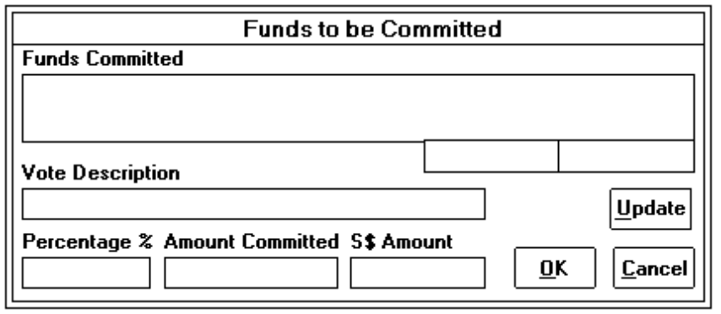
10. The invoice dialog box (Figure 2.8.2) is displayed again when the user selects OK button.
11. Choose one of the following buttons to confirm the entries.
• OK accepts the entries and record will be created. A reference number for filing purpose will be displayed once the invoice is successfully created. User has to write down this number on the received invoice.
• Cancel cancels the entries and record will not be created.

2.8.2 Create Invoices without P/Os.
1. Choose no POs command from the pull down menu of the Invoices command. The following dialog box (Figure 2.8.4) is displayed. Select Add function from the invoice dialog box.
2. Select a Supplier from the 'List of Suppliers' drop-down list box.
3. Enter the invoice number. Please note the invoice number is converted to upper case by the system.
4. By default the date of invoice is the current system date. The value of the financial year and month are also defaulted to the current system year and month.
5. User can select a currency from the Currency drop-down list box if it is not S$. Once the currency is selected, the exchange rate will be displayed. The exchange rate can be overridden if there is a difference.
6. The entry 'S$ Amount' is used to enter the S$ equivalent amount of the invoice amount. Normally, it is computed by the system based on the given exchange rate and the invoice amount. It can be overridden by the user.
Figure 2.8.4: Invoice with P/O Dialog Box
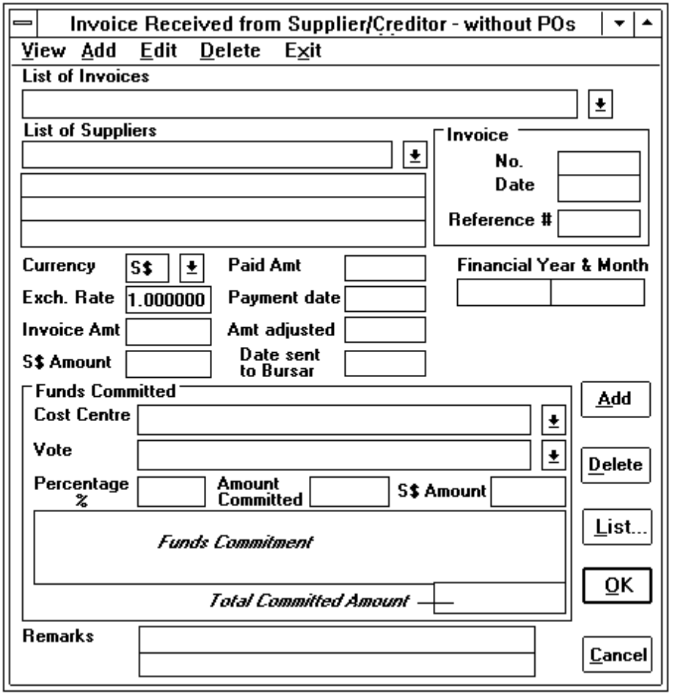
7. By default, the date of invoice to be sent to Bursar's office is 2 working days after the current system date. It can be overridden if it is a public holiday.
8. For the funds commitment, user has to select a cost centre from the Cost Centre drop-down list box. A list of votes of the selected cost centre will be displayed in the Vote drop-down list box for user to select.
9. Once user has selected the vote, the percentage, amount committed and the S$ committed amount are computed by the system. All these entries can be overridden by the user.
10. Choose the Add button to confirm that the selected vote and the amount committed are accepted and it is displayed in the 'Funds Commitment' list box. Repeat procedure 8, 9 and 10 until the total committed amount is equal to the invoice amount.
11. User can choose Delete button to delete a selected funds commitment from the funds committed list box.
12. The description is for general purpose remarks. There are two lines with 40 characters each.
13. Choose one of the following buttons to confirm the entries.
• OK accepts the entries and record will be created. A reference number for filing purpose will be displayed once the invoice is successfully created. User has to write down this number on the received invoice.
• Cancel cancels the entries and record will not be created.

2.8.3 Create Invoices for Staff Travel - Air Fare.
1. Choose Staff Travel - Air Fare command from the pull down menu of the Invoices command and an invoice dialog box (Figure 2.8.5) is displayed.
Figure 2.8.5: Invoice for Staff Travel - Air Fare dialog box
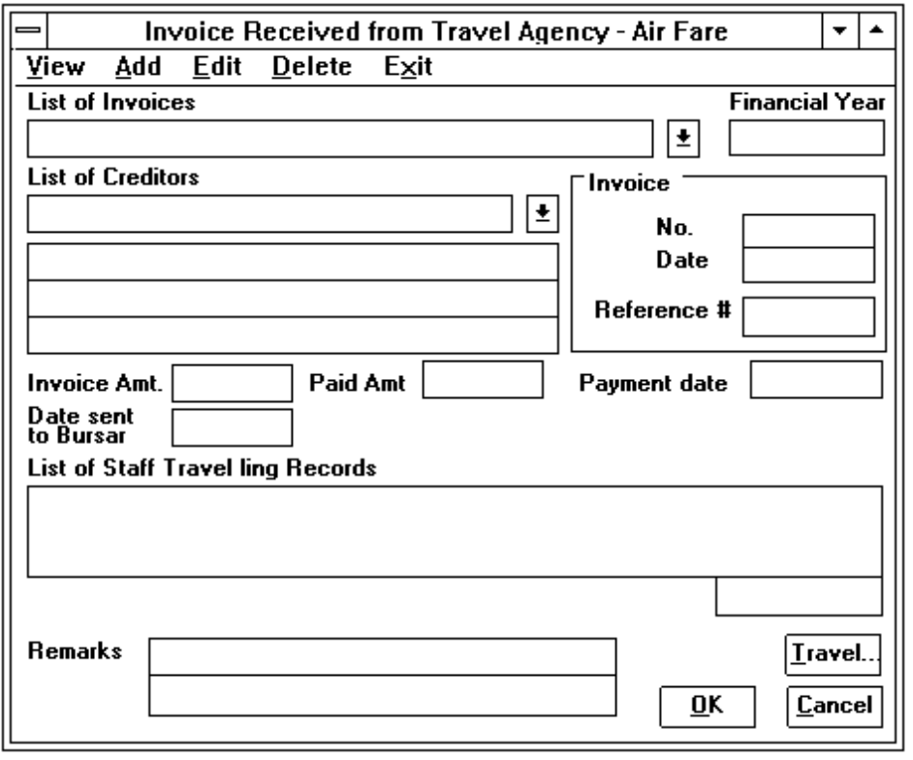
2. Select Add function from the invoice dialog box to enter the invoice received from the travel agency for the air fare of staff travel.
3. Select a creditor from the 'List of Creditors' drop-down list box.
4. Enter the invoice number. Please note the invoice number is converted to upper case by the system.
5. By default, the date of invoice is the current system date whereas the date of invoice to be sent to Bursar's office is 2 days after the current system date.
6. Once the invoice amount is entered, user has to choose Travel button to select a list of the staff travel records that should be charged under this invoice. Another dialog box (Figure 2.8.6) will be displayed when the Travel button is chosen.
Figure 2.8.6: Dialog box for List of Staff Travelling Records
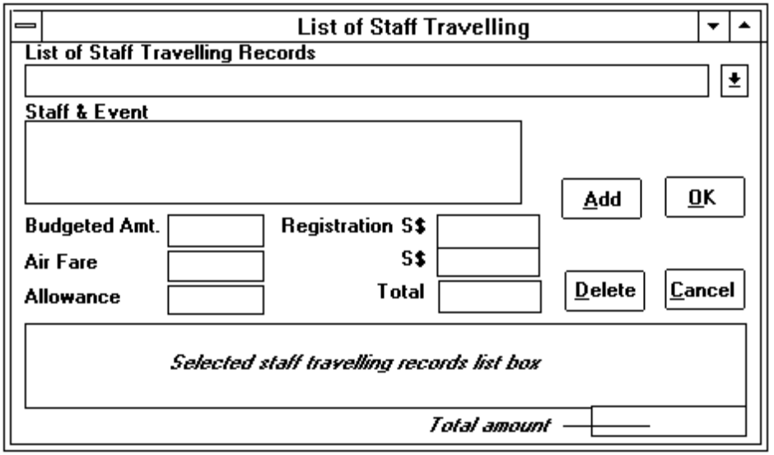
7. Select a staff travel record from the 'List of Staff Travelling Records' list box. The detailed information will be displayed.
8. Enter the Air Fare amount and choose the Add button to add the selected staff travelling record in the 'Selected staff travelling records' list box. Otherwise, choose Cancel button to ignore the entry.
9. Repeat procedure 7 and 8 until the total amount is equal to the invoice amount.
10. User can choose Delete button to delete a selected staff travelling record from the 'Selected staff travelling records' list box.
11. The invoice dialog box (Figure 2.8.5) is displayed again when the user selects OK button.
12. Choose one of the following buttons in the invoice dialog box (Figure 2.8.5) to confirm the entries.
• OK accepts the entries and record will be created. A reference number for filing purpose will be displayed once the invoice is successfully created. User has to write down this number on the received invoice.
• Cancel cancels the entries and record will not be created.

2.8.4 View, Edit or Delete Invoice Records.
1. Choose a command from the pull down menu of the Invoices command (Figure 2.8.1) and an invoice dialog box (refer to Figure 2.8.2, 2.8.4 and 2.8.5) is displayed based on the selected command.
2. Select View, Edit, or Delete function from the invoice dialog box.
3. Choose the List button before selecting an invoice from the 'List of invoices' list box. The following dialog box (Figure 2.8.7) is displayed when user chooses the List button.
Figure 2.8.7: Invoice Selection dialog box
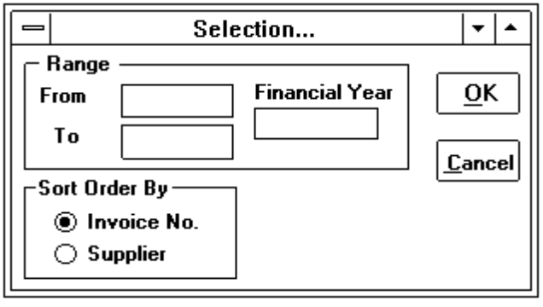
4. Enter the range of the Invoice No. or Supplier (depend on the selection of type of Sort Order by) and the financial year in the above dialog box (Figure 2.7.3). By default, the financial year is the current year and the sequence is ordered by Invoice No.
5. After pressing the OK button, list of invoice records will be displayed in the 'List of invoices' list box (refer to Figure 2.8.2, 2.8.4 and 2.8.5) for user to select.
6. For Edit function, please note that the invoice number cannot be modified. If it is created incorrectly, the user must delete the record and then create the record again.
7. For Delete function, user has to type in the reason of deletion and a confirmation message box (Figure 2.2.4) is always displayed for the user to confirm whether the record should be deleted. Please note that only authorised persons can delete the invoice record. Otherwise, an error message will be displayed to warn the user.
8. For View function, user can view the detailed information of a specified invoice by entering the reference number in the Reference No. text box.

2.9 Updating Credit Notes.
Select Credit Notes command (or press ALT P, C) from the Purchasing menu (Figure 2.7.1). The Credit Note dialog box (Figure 2.9.1) is displayed.
Figure 2.9.1: Credit Note Dialog Box
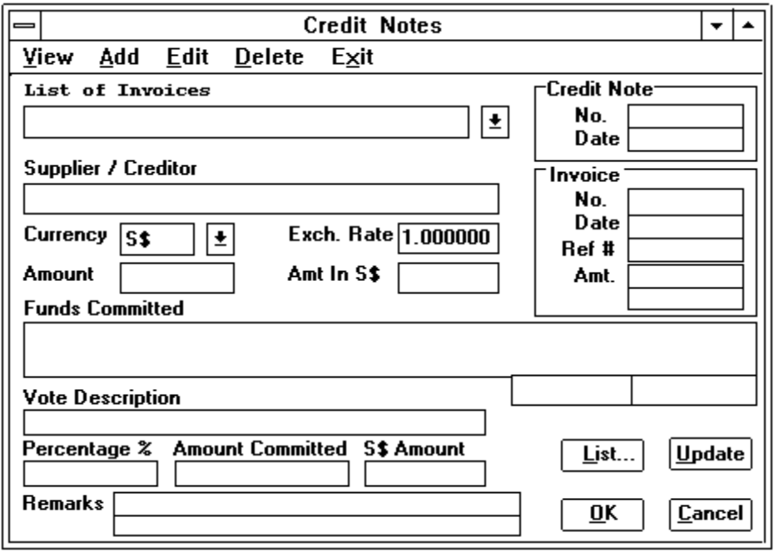

2.9.1. Enter Credit Notes.
1. Select Add function from the Credit Note dialog box (Figure 2.9.1).
2. Select an invoice from the 'List of invoices' drop-down list box. The detailed information of the selected invoice will be displayed.
Note : To get a list of the specified invoices displayed in the 'List of invoices' drop-down list box, user has to choose the List button. For more information about List button, please refer to Section 2.7.2 (para 2 to 4).
3. Enter the credit note number and the date of credit note. By default the date is the current system date.
4. Select a currency from the Currency drop-down list box. By default, it is the same as the currency of the invoice. The exchange rate that is used to compute the equivalent S$ Amount, is displayed after a currency code is selected. The user can amend the exchange rate if it is necessary.
Note : The user can edit the S$ Amount if there is any rounded up differences.
5. User can adjust the vote amount shown in the 'Funds Committed' list box by selecting a vote from it. After re-entering the amount shown in the Amount Committed and S$ Amount text boxes, user has to select Update button to have the updated amount shown in the 'Funds Committed' list box..
6. Choose OK button to save the record. Otherwise, choose Cancel button to ignore the entry.
Note: The credited amount will not affect the original commitment if the selected invoice was received with a P/O raised.

2.9.2 View, Edit or Delete Credit Notes.
1. Select View, Edit or Delete function from the Credit Note dialog box (Figure 2.9.1).
2. Select a credit note record from the 'List of credit notes' (replace list of invoices) list box..
3. The details of the selected record are displayed in the dialog box (Figure 2.9.1). For Edit function, user is able to modify the entries shown in black text except the credit note number.
4. For Delete function, a confirmation message box (Figure 2.2.4) is always displayed for the user to confirm whether the record should be deleted. Please note that only authorised persons can delete the record. Otherwise, an error message will be displayed to warn the user.

2.10 Updating Debit Notes.
Select Debit Notes command (or press ALT P, D) from the Purchasing menu (Figure 2.7.1). The Debit Note dialog box (Figure 2.10.1) is displayed.

2.10.1 Enter Debit Note.
1. Select Add function from the debit note dialog box (Figure 2.10.1).
2. For more information about how to create the debit note record, please refer to Section 2.9.1.

2.10.2 View, Edit or Delete Debit Notes.
1. Select View, Edit or Delete function from the debit note dialog box (Figure 2.10.1).
2. For more information, please refer to Section 2.9.2.
Figure 2.10.1: Debit Note Dialog Box
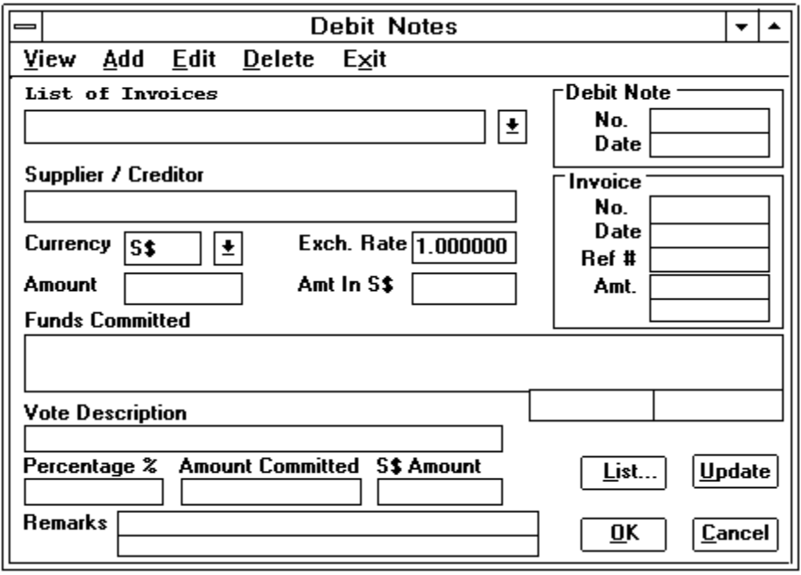

2.11 Cancellation of P/O Items.
Select Cancellation of PO Items command (or press ALT P, N) from the Purchasing menu (Figure 2.7.1). The cancellation of P/O items dialog box (Figure 2.11.1) is displayed.

2.11.1 Enter Cancelled P/O Items.
1. Select Add function from the cancellation of P/O items dialog box (Figure 2.11.1).
2. User can enter the P/O number in the Purchase Order No. text box or select a P/O from the 'List of Purchase Orders' drop-down list box. The detailed information of the selected P/O will appear.
Note : To get a list of the specified P/Os displayed in the 'List of Purchase Orders' drop-down list box, user has to choose the List button. For more information about List button, please refer to Section 2.7.2 (para 2 to 4).
3. Enter the Amount to be cancelled and the S$ Amount will be computed by the system. Please note that the exchange rate cannot be amended, it is the same as the exchange rate of the selected P/O.
4. Update the funds to be cancelled of the committed vote by clicking a vote from the 'Committed Vote A/Cs & Amount' list box. The selected vote and amount will be displayed in the text boxes of Vote Desc, Percentage, Cancelled Amount and Amt. in S$.
Figure 2.11.1: Dialog box for cancellation of P/O items
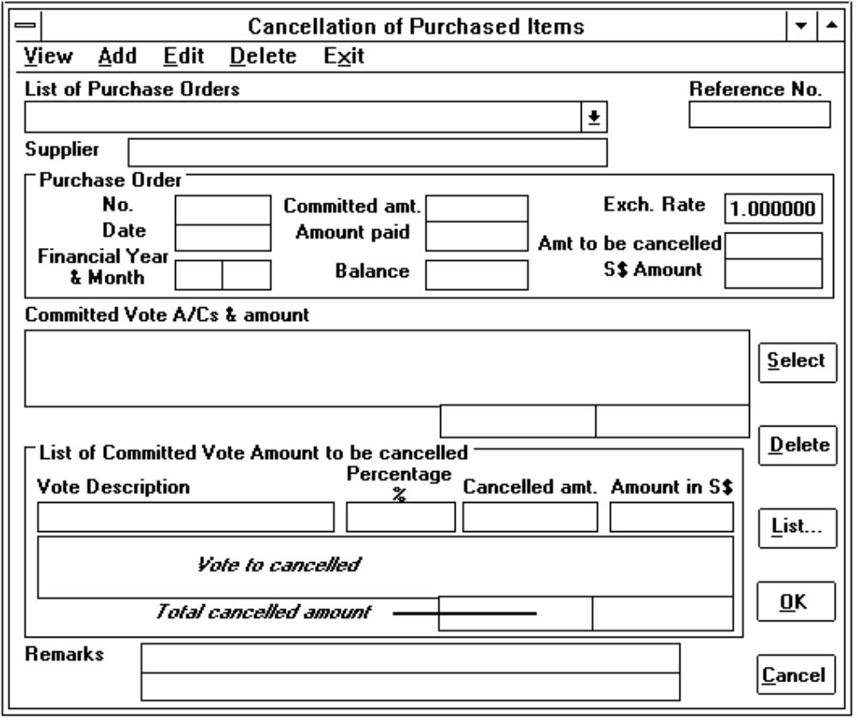
5. Choose the Select button after entering the cancelled amount and S$ amount in the text boxes, the selected vote will be shown in the 'Vote to be cancelled' list box. Repeat the procedure from 4 and 5 until the total cancelled amount is equal to the amount enter in the Amount to be cancelled text box.
6. User can choose Delete button to delete a selected funds to be cancelled from the 'Vote to be cancelled' list box.
7. The remarks is for general purpose remarks. There are two lines with 40 characters each.
8. Choose OK button to save the record and a reference number will be generated by the system. Otherwise, choose Cancel button to ignore the entry.

2.11.2 View, Edit or Delete Cancelled P/O Items.
1. Select View, Edit or Delete function from the cancelled P/O items dialog box (Figure 2.11.1).
2. Choose the List button before selecting a cancelled P/O record from the 'List of purchase orders' drop-down list box. The following dialog box (Figure 2.11.2) is displayed when user chooses the List button.
Figure 2.11.2: Cancelled P/O Selection dialog box
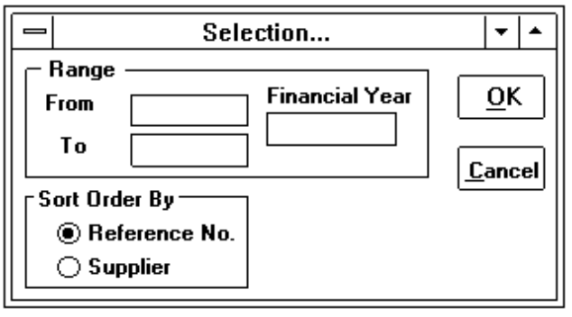
3. Enter the range of the Reference No. or Supplier (depend on the selected type of Sort Order by) and the financial year in the above dialog box (Figure 2.11.2). By default, the financial year is the current year and the Order by option is Reference No.
4. After pressing the OK button, list of cancelled P/O records will be displayed in the 'List of purchase orders' drop-down list box (Figure 2.11.1) for user to select.
5. The details of the selected record are displayed in the dialog box (Figure 2.11.1). For Edit function, user is able to modify the entries shown in black text.
6. For Delete function, a confirmation message box (Figure 2.2.4) is always displayed for the user to confirm whether the record should be deleted. Please note that only authorised persons can delete the record. Otherwise, an error message will be displayed to warn the user.

2.12 Preparing Claims /Payments Records.
There are three types of claims/payments provided in the system. Select Claims / Payments command (or press ALT E, C) from the Expenses/Reimbursement menu and then a pull down menu (Figure 2.12.1) is displayed. The user can choose options for entering invoices from the pull down menu.
Figure 2.12.1: Claims/Payment pull down menu
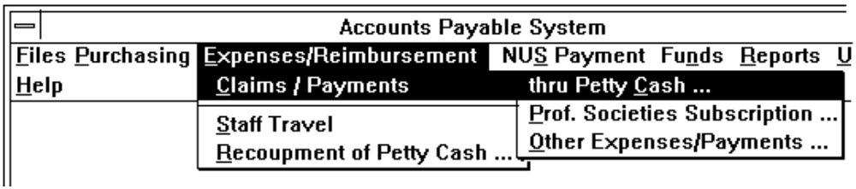

2.12.1 Create Claims/Payments Thru Petty Cash.
1. Select the thru Petty Cash command from the pull down menu (Figure 2.12.1). The petty cash dialog box (Figure 2.12.2) is displayed.
Figure 2.12.2: Petty Cash Dialog Box
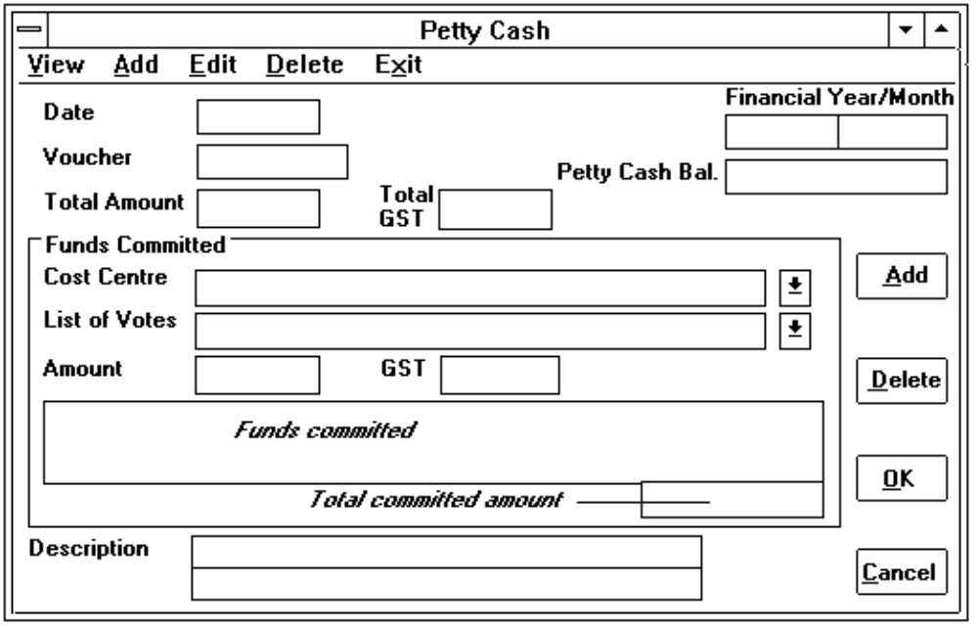
2. Choose Add Function from the dialog box.
3. Enter the date. By default, it is the current system date. The financial year and month are also defaulted to the year and month of the date entered.
4. Enter the Voucher number. It is converted to upper case by the system.
5. Enter the total amount and GST claimed by the staff member. Please note that the GST is excluded in the total amount. Only the total amount will be taken as the funds commitment.
6. For the funds commitment, user has to select a cost centre from the Cost Centre drop-down list box. A list of votes of the selected cost centre will be displayed in the 'List of votes' drop-down list box for user to select.
7. Once user has selected the vote, the amount committed and the GST are computed by the system. All these entries can be overridden by the user.
8. Choose the Add button to confirm that the selected vote and the amount committed are accepted and it is displayed in the 'Funds committed' list box. Repeat procedure 6, 7 and 8 until the total committed amount is equal to the total amount.
9. User can choose Delete button to delete a selected funds commitment from the 'Funds committed' list box.
10. The description is for general purpose remarks. There are two lines with 40 characters each.
11. Choose OK button to save the record. Otherwise, choose Cancel button to ignore the entry.

2.12.2 Create Claims/Payments For Professional Societies Subscription.
1. Select the Prof. Societies Subscription command from the pull down menu (Figure 2.12.1). The claims for subscription to professional societies dialog box (Figure 2.12.3) is displayed.
Figure 2.12.3: Claims for Subscription to Professional Societies dialog box
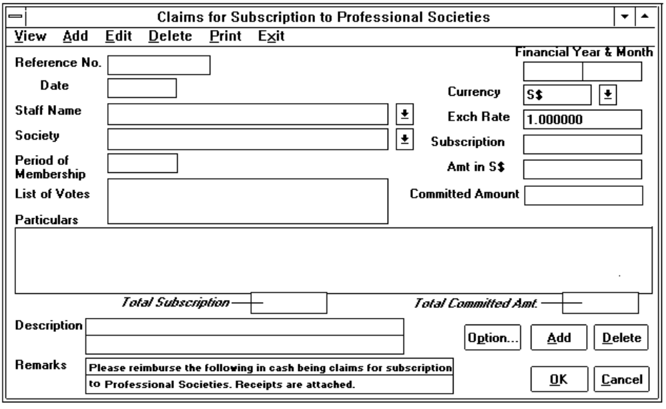
2. Choose Add function from the dialog box.
3. Enter the date. By default, it is the current system date. The financial year and month are also defaulted to the year and month of the date entered.
4. Select a staff from the 'Staff Name' drop-down list box. If the staff name does not exist, please inform the system administrator. Once a staff member is selected, a list of cost centres that the staff belonged will be displayed in the 'List of votes' list box. If there is any changes, choose the Option button to amend the cost centres. For more information about Option button, please refer to Section 2.19.
5. Select a approved professional society from the Society list box.
6. Select a currency from the Currency drop-down list box. By default, it is S$. The exchange rate that is used to compute the equivalent S$ Amount, is displayed after a currency code is selected. The user can type in the exchange rate if it is necessary.
7. Enter the subscription amount and the S$ amount will be computed by the system based on the exchange rate. The committed amount is also computed by the system. Please note that this amount cannot be overridden by the user.
8. Enter the period of the membership. By default, it is always set to the current year.
9. Choose the Add button to confirm that the subscription of the selected staff member is accepted and it is displayed in the Particulars list box. Repeat the procedure from 4 to 9 if it is necessary.
10. User can choose Delete button to delete a selected subscription of a staff member from the Particulars list box.
11. The description is for general purpose remarks. There are two lines with 40 characters each.
12. The remarks is used to be printed in the Claims letter to NUS Bursar's Office. It can be overridden by the user.
13. Choose one of the following buttons to confirm the entries.
• OK saves the entries and record will be created. A reference number for filing purpose will be generated once the record is successfully created.
• Cancel cancels the entries and record will not be created.

2.12.3 Create Claims/Payments For Other Expenses/Payments.
1. Select the Other Expenses/Payments command from the pull down menu (Figure 2.12.1). The Other Expenses/Payments dialog box (Figure 2.12.4) is displayed.
2. Choose Add function from the dialog box.
3. Enter the date. By default, it is the current system date. The financial year and month are also defaulted to the year and month of the date entered.
4. User can select a currency from the Currency drop down list box if it is not S$. Once the currency is selected, the exchange rate will be displayed. The exchange rate can be overridden if there is a difference.
5. The entry 'Total S$ Amount' is used to enter the S$ equivalent amount of the amount entered in Amount text box. Normally, it is computed by the system based on the given exchange rate and the amount. It can be overridden by the user.
Figure 2.12.4: Other Expenses/Payments dialog box
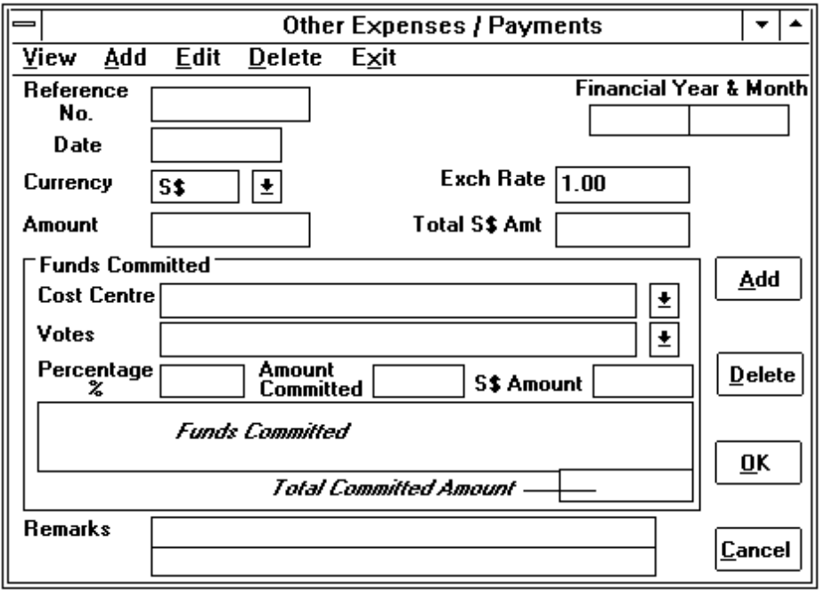
6. For the funds commitment, user has to select a cost centre from the Cost Centre drop-down list box. A list of votes of the selected cost centre will be displayed in the Votes drop-down list box for user to select.
7. Once user has selected the vote, the percentage, amount committed and the S$ committed amount are computed by the system. All these entries can be overridden by the user.
8. Choose the Add button to confirm that the selected vote and the amount committed are accepted and it is displayed in the funds commitment list box. Repeat procedure 6, 7 and 8 until the total committed amount is equal to the total amount.
9. User can choose Delete button to delete a selected funds commitment from the 'Funds committed' list box.
10. The description is for general purpose remarks. There are two lines with 40 characters each.
11. Choose OK button to save the record and a reference number is generated. Otherwise, choose Cancel button to ignore the entry.

2.12.4 View, Edit or Delete Claims/Payments Records.
1. Choose a command from the pull down menu of the Expenses/Reimbursement command (Figure 2.12.1) and a claims/payments dialog box (refer to Figure 2.12.2, 2.12.3 and 2.12.4) is displayed based on the selected command.
2. Select View, Edit, or Delete function from the claims/payments dialog box.
3. Select a record from the 'Reference No.' or 'Voucher No.' (for petty cash) drop-down list box. The detailed information of the selected record will be displayed in the dialog box.
4. For Edit function, please note that the reference/voucher number cannot be modified. If it is created incorrectly, the user must delete the record and then create it again.
5. For Delete function, a confirmation message box (Figure 2.2.4) is always displayed for the user to confirm whether the record should be deleted. Please note that only authorised persons can delete the record. Otherwise, an error message will be displayed to warn the user.

2.12.5 Print the Claims Request Letter.
1. Choose Print command from Claims for Subscription to Professional Societies dialog box (Figure 2.12.3) and then Letter To Bursar's Office command from the pull down menu (Figure 2.12.5).
Figure 2.12.5: Pull down menu command of Print menu
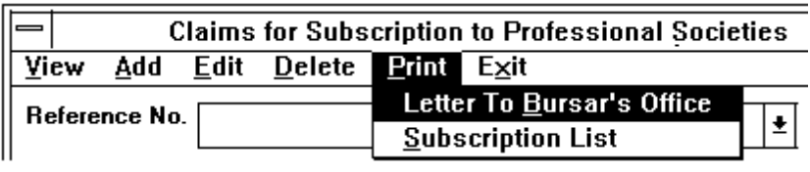
2. Select a record from the 'Reference No.' drop-down list box. The report (refer to Appendix A/7) will be generated and printed at the HP Laser Printer.

2.12.6 Print Claims for Subscription to Professional Societies Report.
1. Choose Print command from Claims for Subscription to Professional Societies dialog box (Figure 2.12.3) and then Subscription List command from the pull down menu (Figure 2.12.5).
2. For more information of how to print this report, please refer to Section 2.20.6 para 2 to 4.

2.13 Updating Staff Travelling Records.
There are two types of staff travelling provided in the system. Select Staff Travel command (or press ALT E, S) from the Expenses/Reimbursement menu and then a pull down menu (Figure 2.13.1) is displayed. The user can choose options for entering invoices from the pull down menu.
Figure 2.13.1: Staff Travel pull down menu command
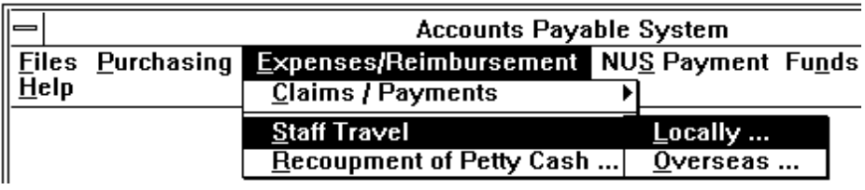

2.13.1 Create Staff Travel Records.
1. Select the Locally or Overseas command from the pull down menu (Figure 2.13.1) depend on the type of staff travel. The staff travel dialog box (Figure 2.13.2) is displayed. Please note the staff travel dialog box of both types are similar except the dialog box's menu title is different.
Figure 2.13.2: Staff Travel Locally dialog box
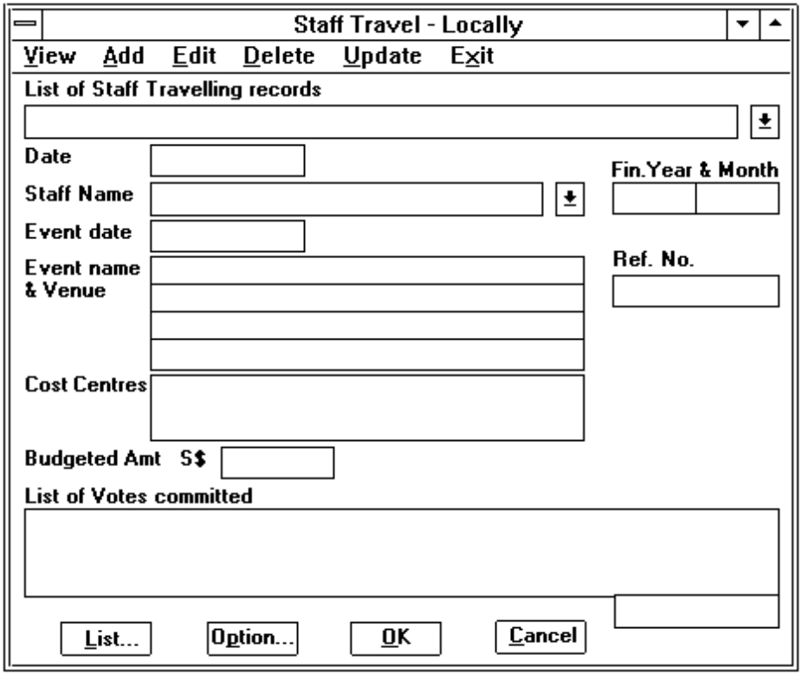
2. Select Add function from the dialog box.
3. Enter the date. By default, it is the current system date. The financial year and month are also defaulted to the year and month of the date entered.
4. Select a staff from the Staff Name drop-down list box. If the staff name does not exist, please inform the system administrator. Once a staff member is selected, a list of cost centre that the staff belonged will be displayed in the Cost Centres list box. If there is any changes, choose the Option button to amend the cost centres. For more information about Option button, please refer to Section 2.19.
5. Enter the date of event and the description of the event. There are 4 lines with 40 characters each provided for the event name & venue.
6. Enter the budgeted amount (it should be in S$). After entering the budgeted amount, a list of the funds committed is displayed in the 'List of Votes committed' list box.
7. Choose OK button to save the record and a reference number is generated. Otherwise, choose Cancel button to ignore the entry.

2.13.2 View, Edit or Delete Staff Travelling Records.
1. Select View, Edit, or Delete function from the staff travel dialog box (Figure 2.13.2).
2. Choose the List button before selecting a staff travel record from the 'List of Staff Travelling records' drop-down list box. The following dialog box (Figure 2.13.3) is displayed when user chooses the List button.
Figure 2.13.3: Staff Travelling records Selection dialog box
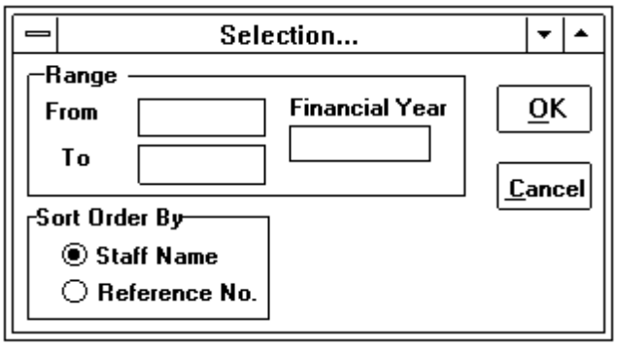
3. Enter the range of the Staff Name. or Reference No. (depend on the selected type of Sort Order by) and the financial year in the above dialog box (Figure 2.13.3). By default, the financial year is the current year and the sequence is ordered by staff name.
4. After pressing the OK button, a list of staff travelling records will be displayed in the 'List of Staff Travelling records' drop-down list box (Figure 2.13.2) for user to select.
5. For Edit function, user is able to modify all the entries except reference number.
6. For Delete function, a confirmation message box (Figure 2.2.4) is always displayed for the user to confirm whether the record should be deleted. Please note that only authorised persons can delete the record. Otherwise, an error message box is displayed to warn the user.

2.13.3 Update Staff Travelling Records.
1. Select Update function from the staff travel dialog box (Figure 2.13.2), the staff travel dialog box will be displayed as follows (Figure 2.13.4).
Figure 2.13.4: Staff Travel dialog box for updating
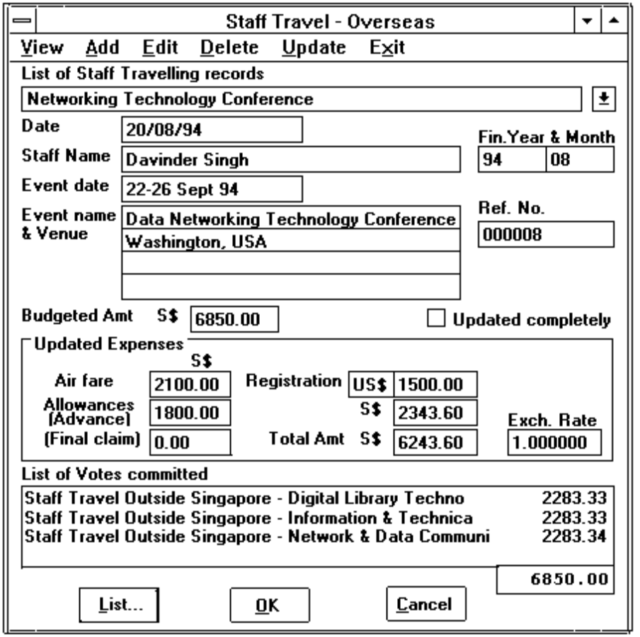
2. Choose the List button before selecting a staff travel record from the 'List of Staff Travelling records' drop-down list box. For more information about the List button, please refer Section 2.13.2 (para 2 to 4).
3. The detailed information of the selected staff travelling record is displayed in the dialog box (Figure 2.13.4).
4. Enter the amount in Allowances (Advance), Final Claim and Registration text boxes. By default, the currency of registration is S$. User can change the currency by clicking on the Currency text box and select a currency from the Currency drop-down list box.
Note: The Air Fare is unable to be updated from here, user has to update it by selecting the Staff Travel -Air Fare command from the Invoices command pull down menu (ref to Section 2.8.3).
5. The 'Update completely' check box is used to indicate whether the selected staff travel record has been fully updated. By default, it is unchecked (update partially). The funds committed in the 'List of votes committed' list box will be updated based on the amount shown in the Total Amount text box, if user choose updated completely (marked with 'x' in the check box).
6. Choose OK button to update the record. Otherwise, choose Cancel button to ignore the entry.

2.14 Recoupment of Petty Cash.
1. When user received the reimbursed petty cash from NUS Bursar's office, he/she has to update the petty cash balance. Select Recoupment of Petty Cash command (or press ALT E, R) from the Expenses/Reimbursement menu.
2. The following dialog box is (Figure 2.14.1) displayed.
Figure 2.14.1: Recoupment of Petty Cash dialog box
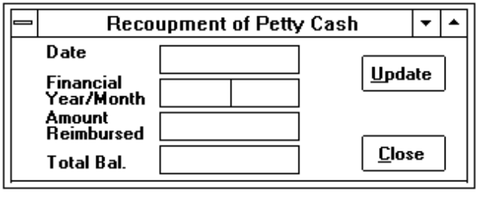
3. Enter the date. By default, it is the current system date. The financial year and month are also defaulted to the year and month of the date entered.
4. Enter the amount reimbursed and the total balance will be computed and displayed by the system.
5. Choose Update button to accept the entries and the record will be updated. Otherwise, choose Cancel button to ignore the entries.
Note: If the total balance shown in the 'Total Bal.' text box is more than 500, the system will not accept this entry and the petty cash balance will not be updated.

2.15 NUS Payment Update.
For cash payment made by NUS Bursar's Office, user has to update it for invoices, other expenses payments and prepaid P/Os without receiving any invoice.
Figure 2.15.1: NUS Payment menu command
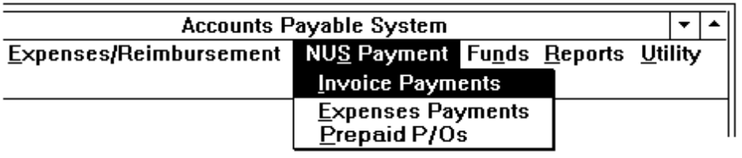

2.15.1 Updating Cash Payment of an Invoice.
1. Select Invoice Payments command from the NUS Payment menu (or press ALT S, I). The following dialog box (Figure 2.15.2) is displayed.
Figure 2.15.2: Dialog box for Cash Payment of an Invoice
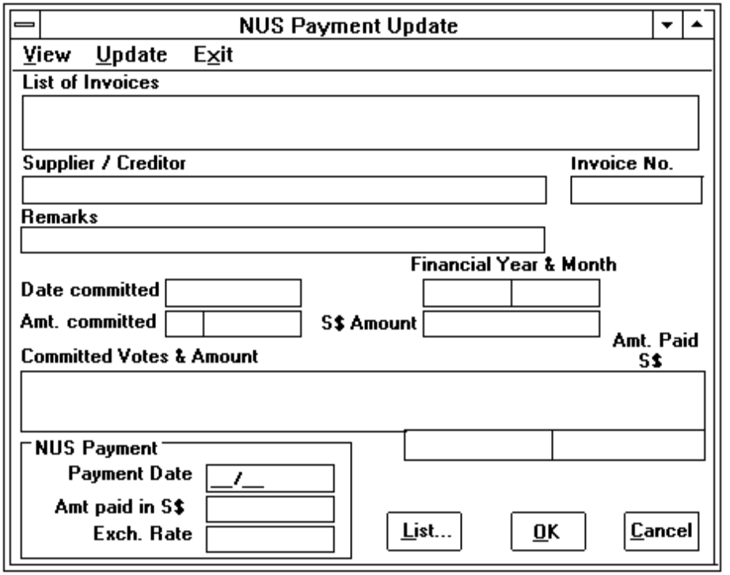
2. Select Update function from the above dialog box.
3. Select an Invoice from the 'List of invoices' dorp-down list box. Please choose List button for selecting a list of specified invoices in the 'List of invoices' dorp-down list box. For more information about List button, please refer to Section 2.8.4 (para 3 to 5).
4. The detailed information of the selected invoice is displayed in the dialog box.
5. Enter the Payment Date in the format of MM/YY where MM and YY are the month and year respectively .
6. Enter the Amount paid in S$. If the amount paid is different from the invoice amount, then a new exchange rate is computed and displayed in the Exch. Rate text box.
7. Choose OK button to update the payment. Otherwise, choose Cancel key to ignore the entry.

2.15.2 Updating Cash Payment of Expenses Payments.
1. Select Expenses Payments command from the NUS Payment menu (or press ALT S, E). The following dialog box (Figure 2.15.3) is displayed.
Figure 2.15.3: Dialog box for Cash Payment of Expenses Payments
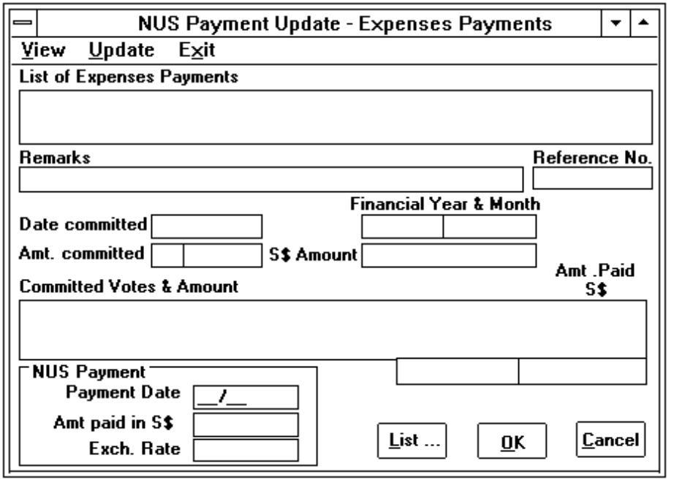
2. Select Update function from the above dialog box.
3. Select a expenses payment from the 'List of Expenses Payments' drop-down list box. Please choose List button for selecting a list of specified expenses payments in the 'List of Expenses Payments' drop-down list box. For more information about List button, please refer to Section 2.8.4 (para 3 to 5).
4. The detailed information of the selected record is displayed in the dialog box.
5. Enter the Payment Date in the format of MM/YY.
6. Enter the Amount paid in S$. If the amount paid is different from the invoice amount, then the new exchange rate is computed and displayed in the Exch. Rate text box.
7. Choose OK button to update the payment. Otherwise, choose Cancel key to ignore the entry.

2.15.3 Updating Cash Payment of P/O with Prepayment.
1. Select Prepaid P/Os command from the NUS Payment menu (or press ALT S, P). For more information about updating the cash payment, please refer to Section 2.15.1 (para 2 to 7).

2.15.4 View Cash Payment of Invoice, Expenses Payments or Prepaid P/Os.
1. Choose a command from the NUS Payment menu (or press ALT S, E). A cash payment dialog box (refer to Figure 2.15.2 and 2.15.3) is displayed based on the selected command.
2. Select View function from the dialog box.
3. Select a record from the 'List of Invoices (Expenses payments or P/Os)' drop-down list box. Please choose List button for selecting a list of specified expenses payments in the 'List of Invoices (Expenses payments or P/Os)' drop-down list box. For more information about List button, please refer to Section 2.8.4 (para 3 to 5).
4. The detailed information of the selected record will be displayed in the dialog box.

2.16 Preparing Journal Adjustment.
Select Journal Adjustment command from the Funds menu. The following dialog box (Figure 2.16.2) is displayed.
Figure 2.16.1: NUS Payment menu command
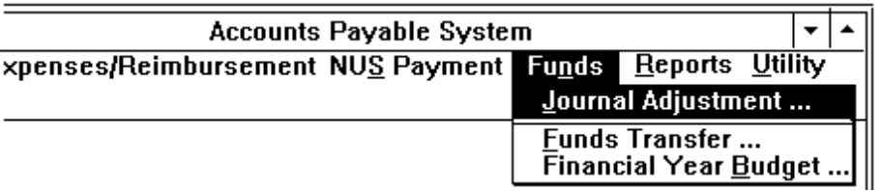

2.16.1 Create a Journal Adjustment.
1. Select Add function from the journal adjustment dialog box (Figure 2.16.2).
2. Enter the Reference number. It will be converted to upper case by the system. Please note that the reference number can be duplicated.
Note: The sequence number in the Seq No. text box is generated by the system.
3. Enter the date. By default, it is the current system date. The financial year and month will be defaulted to the year and month of the date entered.
Figure 2.16.2 Journal Adjustment dialog box
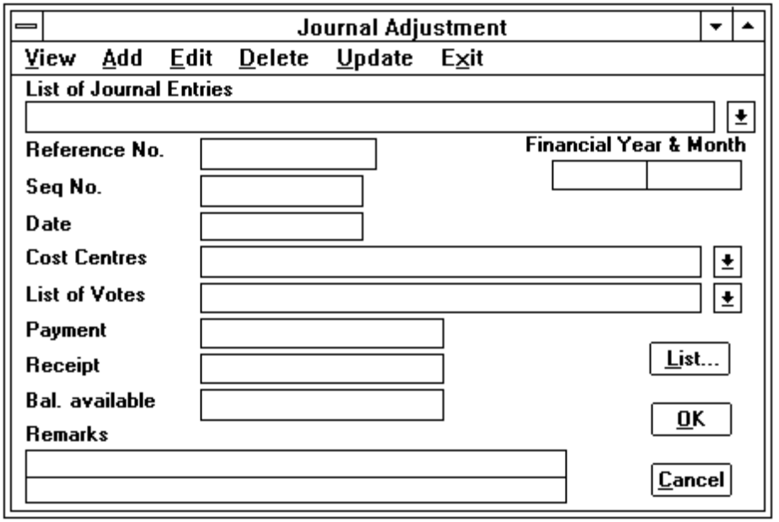
4. Select a cost centre from the 'Cost Centres' drop-down list box. A list of votes of the selected cost centre will be displayed in the 'List of votes' drop-down list box.
5. Choose OK button to save the record and a reference number is generated. Otherwise, choose Cancel button to ignore the entry.

2.16.2 Edit or Delete a Journal Adjustment.
1. Select Edit or Delete function from the journal adjustment dialog box (Figure 2.16.2).
2. Choose the List button before selecting a journal entry from the 'List of journal entries' drop-down list box. The following dialog box (Figure 2.16.3) is displayed when user chooses the List button.
Figure 2.16.3: Journal Entries Selection dialog box
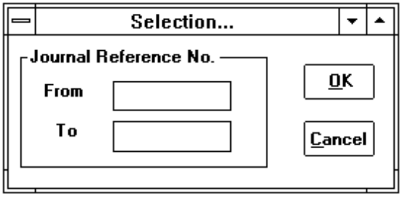
3. Enter the range of the journal reference number.
4. After pressing the OK button, a list of the specified journal records will be displayed in the 'List of journal entries' drop-down list box (Figure 2.16.2) for user to select.
5. For Edit function, user is able to modify all the entries except reference number and sequence number.
6. For Delete function, a confirmation message box (Figure 2.2.4) is always displayed for the user to confirm whether the record should be deleted.

2.16.3 View and Print Journal Adjustment Report.
1. Select View function from the journal adjustment dialog box (Figure 2.16.2). A dialog box (Figure 2.16.3) will be displayed for user to enter the range of the journal reference number.
2. After pressing the OK button in the dialog box (Figure 2.16.3), a list of the specified journal entries will be displayed in the following dialog box (Figure 2.16.4).
Figure 2.16.4: Dialog box for displaying List of Journal Adjustments
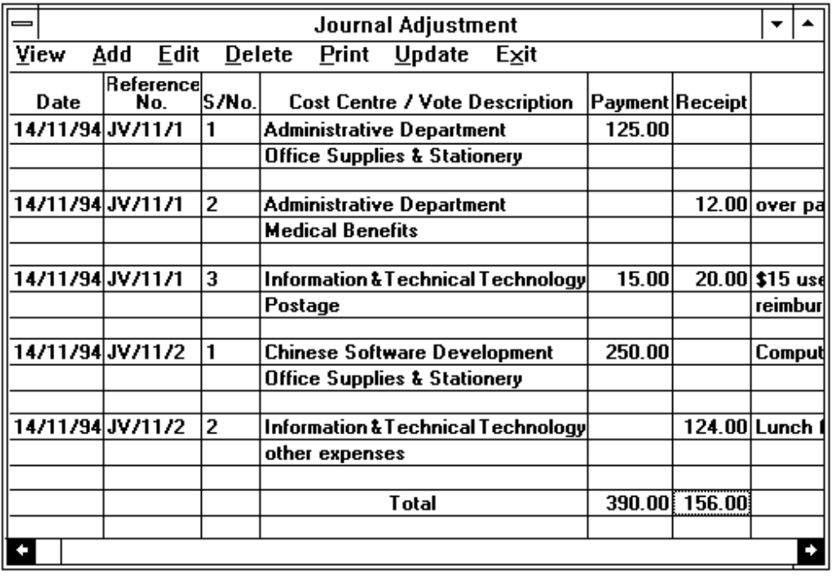
3. Choose Print function from the above dialog box if you would like to print the Journal Adjustment report (refer to Appendix A/13).
Note: The report will be printed to the Epson dot-matric printer.

2.16.4 Update Journal Adjustment.
1. Select Update function from the journal adjustment dialog box (Figure 2.16.2).
2. During updating, a message 'Update Journal Adjustment transactions in Progress !' is displayed.
3. Another message box 'Update Completed !' will be displayed when all the entries have been successfully updated.
Note: Once the records have been updated, user is unable to view, edit or delete any one of the entries. If there is error, user has to re-adjust the record by posting another journal adjustment.

2.17 Funds Transfer.
For funds transfer, only authorised user is able to access this function. Select Funds Transfer command from the Funds menu (or press ALT N, F). The following dialog box (Figure 2.17.1) is displayed.
Figure 2.17.1: Funds Transfer dialog box
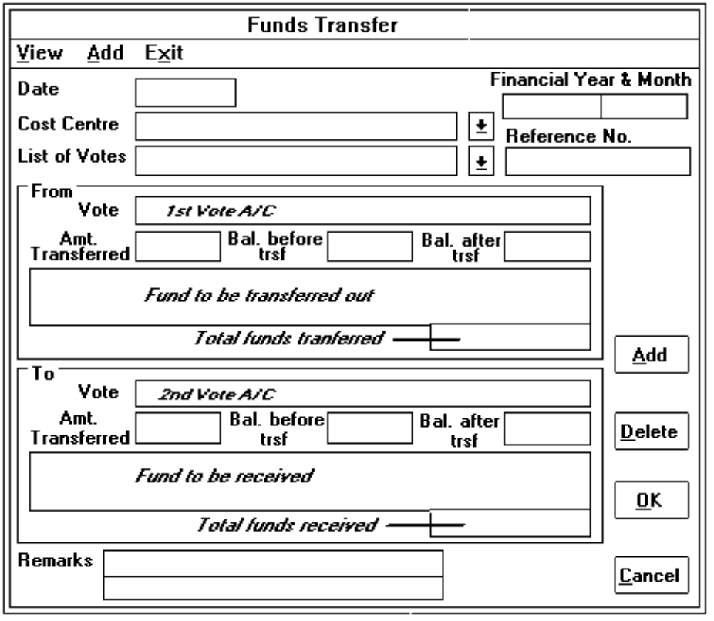

2.17.1 Transferring funds.
1. Select Add function from the funds transfer dialog box.
2. Enter the date. By default, it is the current system date. The financial year and month will be defaulted to the year and month of the date entered.
3. Move the cursor at the 1st Vote A/C text box and the cursor will be set at the 'Cost Centre' drop-down list box. Select a cost centre from the cost centre list box, then a list of votes of the selected cost centre will be displayed in the 'List of votes' drop-down list box. After selecting a vote record, the vote description will be displayed in the 1st Vote A/C text box.
4. Enter the amount to be transferred in the Amt. Transferred text box.
5. Choose Add button to insert the vote record in the Fund to be transferred out list box.
Note: Balance before transferred, balance after transferred and the total funds transferred are generated by the system after Add button is chosen.
6. Repeat the procedure 3 to 5 until you have added in the list of votes to be transferred.
7. To insert a vote record in the Fund to be received list box, just move the cursor at the 2nd Vote A/C text box. User is able to select a cost centre and vote record from the 'Cost Centre' and 'List of votes' drop-down list box respectively (refer to para 3).
8. Enter the amount to be transferred in the Amt. Transferred text box.
9. Choose Add button to insert the vote record in the Fund to be received list box.
10. To delete a selected vote record in the 'Fund to be transferred out' or 'Fund to be received' list box, choose Delete button after clicking a vote from one of the list box.
11. The remarks is for general purpose remarks. There are two lines with 40 characters each.
12. Choose OK button to save the record and a reference number is generated. Otherwise, choose Cancel button to ignore the entry.
Note: The total funds transferred and total funds received should be equal before choosing OK button to update the record.

2.17.2 View Funds Transfer.
1. Select View function from the funds transfer dialog box (Figure 2.17.1).
2. The following selection dialog box (Figure 2.17.2) will be displayed for user to enter the financial year and the range of financial month. By default, they are the current system month and year.
3. The detailed information of the specified funds transfer transactions will be displayed in the following dialog box (Figure 2.17.3).
Figure 2.17.2: Dialog box for selecting financial month & year
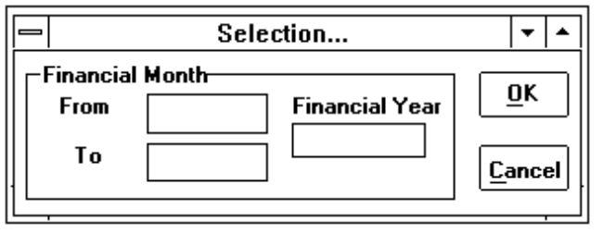
4. Choose Print function from the dialog box (Figure 2.17.3) and the fund transfer transaction report (Appendix A/17) will be printed to the Epson dot-matric printer.
Figure 2.17.3: Dialog box for displaying Funds Transfer transactions
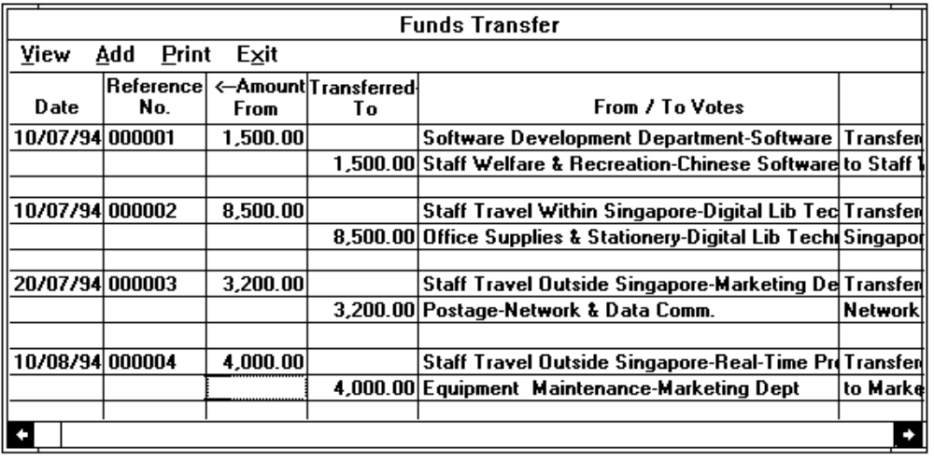

2.18 Preparing Budget Accounts For A Financial Year.
For financial year budget, only authorised user is able to access this function. Select Financial Year Budget command from the Funds menu (or press ALT N, B). The following dialog box (Figure 2.18.1) is displayed.

2.18.1 Create A Budget Account.
1. Select Add function from the financial year budget dialog box.
2. Select a cost centre from the 'Cost Centres' drop-down list box and a list of votes of the selected cost centre will be displayed in the 'List of votes' drop-down list box for user to select.
3. Select a vote from the 'List of votes' drop-down list box, then the description of the selected vote and cost centre will be displayed in the description text box.
4. Enter the financial year. By default, it is the year of the current system date.
Figure 2.18.1: Dialog box for financial year budget
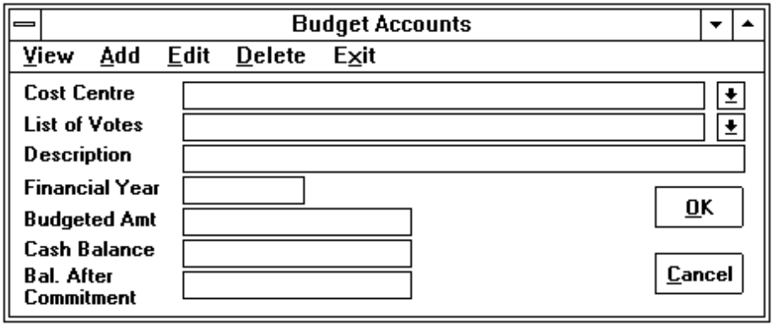
5. Enter the budgeted amount.
6. Choose OK button to save the record. Otherwise, choose Cancel button to ignore the entry.

2.18.2 View And Print Budget Account.
1. Select View function from the financial year budget dialog box (Figure 2.18.1). A dialog box (Figure 2.18.2) will be displayed for user to select options for displaying the budget accounts.
Figure 2.18.2: Budget Selection Dialog Box
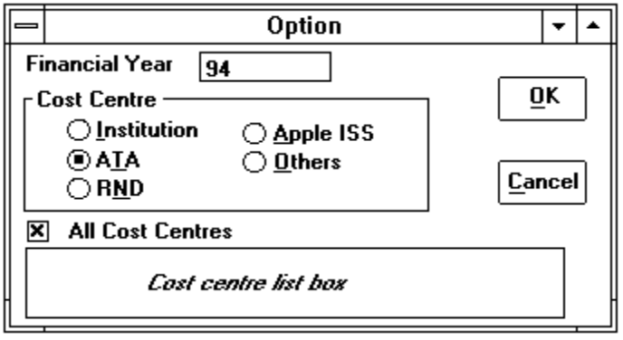
2. Enter the financial year. By default, it is the year of the current system date.
3. Select an option from the cost centre group box. By default, it is ATA.
Option Remarks
Institution All cost centres
ATA Cost centres of ATA only
RND Cost centres of RND only
Apple-ISS Cost centre of Apple-ISS only
Others Other cost centres
4. All cost centres of the selected option will be displayed in the 'Cost Centres' list box. If the check box of All Cost Centres is unchecked, then user can select a list of cost centres from the 'Cost Centres' list box by clicking the records in the list box.
5. Choose OK button to display the budget account in the following dialog box (Figure 2.18.3). Otherwise choose Cancel button to ignore the entry.
Figure 2.18.3: Budget Selection Dialog Box
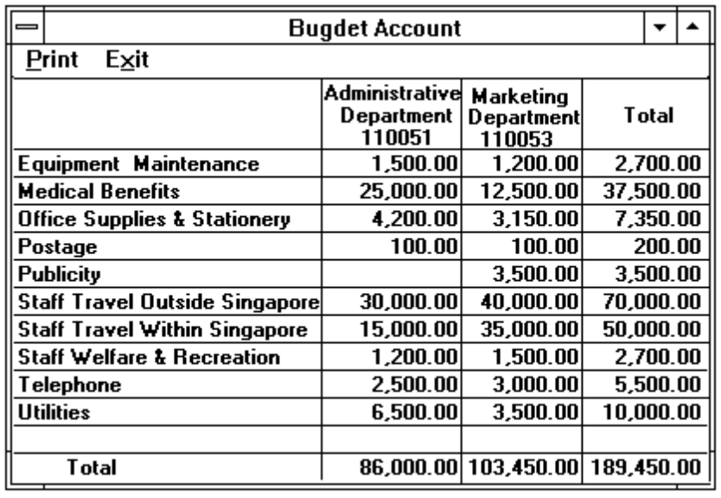
6. Choose Print function from the above dialog box if you want the budget account report (Appendix A/16) to be printed. Otherwise, choose Exit function to close the dialog box.

2.18.3 Edit or Delete A Budget Account.
1. Select Edit or Delete function from the financial year budget dialog box (Figure 2.18.1).
2. Select a cost centre from the 'Cost Centres' drop-down list box and a list of votes of the selected cost centre will be displayed in the 'List of votes' drop-down list box for user to select.
3. Select a vote from the 'List of votes' drop-down list box, then the description of the selected vote and cost centre will be displayed in the description text box.
4. Enter the financial year. By default, it is the year of the current system date.
5. For Edit function, user is able to modify the budgeted amount.
6. For Delete function, a confirmation message box (Figure 2.2.4) is always displayed for the user to confirm whether the record should be deleted.

2.19 Maintaining Cost Centres of Staff Record.
To maintain the cost centre of a staff member, user can choose the Option button from any one of the dialog boxes: Staff Travel ( Figure 2.13.2) and Claims for subscription to Professional Societies (Figure 2.12.3). The following dialog box will be displayed.
Figure 2.19.1: Staff Information Dialog Box
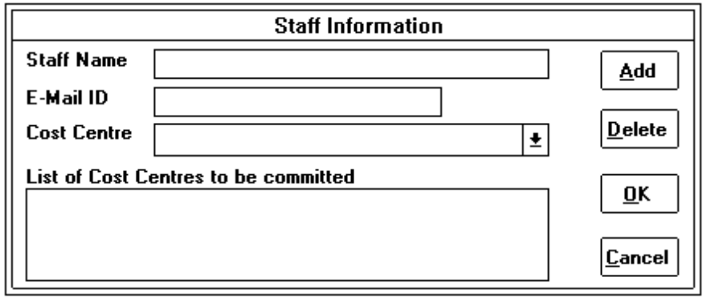
1. The selected staff name and E-mail ID will be displayed in the text boxes. User is unable to amend them.
Note: The staff name should be selected from the 'Staff Name' drop-down list box in dialog boxes (Figure 2.12.3 or 2.13.2) before choosing the Option button.
2. A list of the cost centres of the staff will be displayed in the 'List of cost centres to be committed' list box if there is any cost centre assigned to the selected staff.
3. To remove a cost centre from the 'List of cost centres to be committed' list box, user has to click on the cost centre and choose the Delete button.
4. To insert a cost centre into the 'List of cost centres to be committed' list box, select a cost centre from the 'Cost Centre' drop-down list box and choose the Add button.
5. Choose OK button to accept the entries and the record will be updated. Otherwise, choose Cancel button to ignore the entry.

2.20 Producing Standard Reports.
From the Reports menu (Figure 2.12.1), the user can choose a command for producing each of the standard reports. The user instructions are given below.
Figure 2.20.1: Reports Menu Command
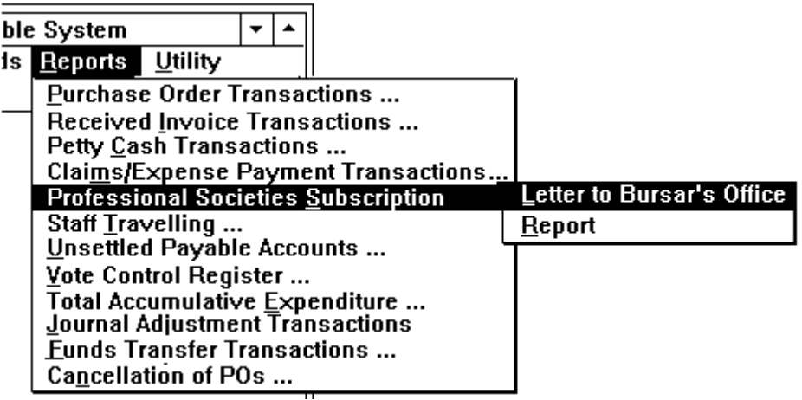

2.20.1 Producing Purchase Order Transactions Report.
1. Select Purchase Order Transactions command from the Reports menu.
2. The following selection dialog box (Figure 2.20.2) will be displayed for user to enter the financial year and the range of financial month. By default, they are the current system month and year.
Figure 2.20.2: Dialog box for selecting the range of P/Os
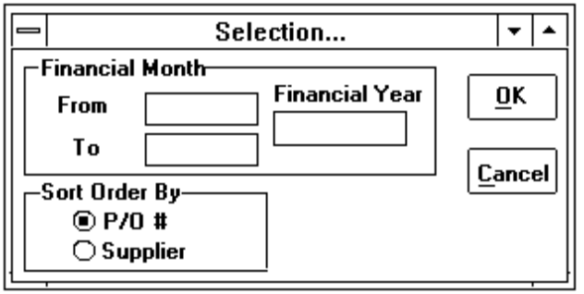
3. Choose P/O# or Supplier option in the Sort Order by group box.
4. The report (refer to Appendix A/2) will be shown in the dialog box.
5. Choose Print function from the above dialog box (Figure 2.20.3) to print the report. The report is then printed to Epson dot-matrix printer.
Note: A message box with the message 'Please collect your report from the printer !' will be displayed once the report is completely generated. Press OK button to close the message box.
6. Choose the Exit function to close the dialog box.
Figure 2.20.3: Dialog box for displaying the report
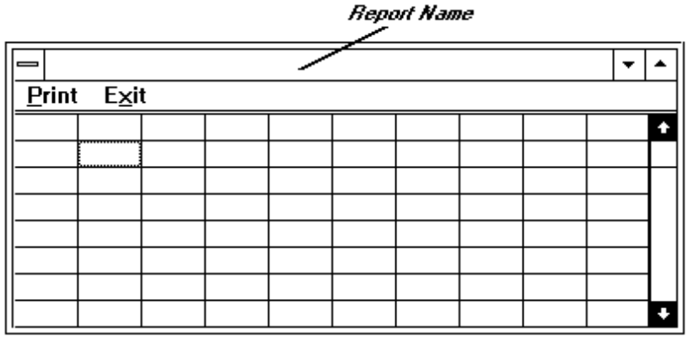

2.20.2 Producing Received Invoice Transactions Report.
1. Select Received Invoice Transactions command from the Reports menu.
2. The following selection dialog box (Figure 2.20.4) will be displayed for user to enter the financial year and the range of financial month. By default, they are the current system month and year.
Figure 2.20.4: Dialog box for selecting the range of invoices
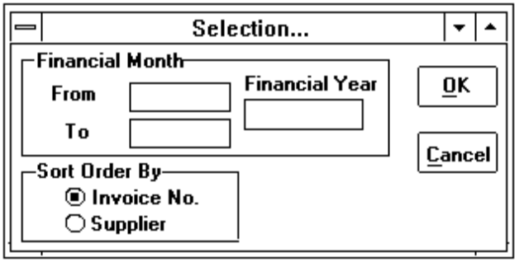
3. Choose Invoice No or Supplier option in the Sort Order by group box.
4. The report (refer to Appendix A/3) will be shown in the dialog box (Figure 2.20.3).
5. For more information about how to print the report, please refer to Section 2.20.1 para 5 and 6.

2.20.3 Producing Petty Cash Transactions Report.
1. Select Petty Cash Transactions command from the Reports menu.
2. A selection dialog box (Figure 2.17.2) will be displayed for user to enter the financial year and the range of financial month. By default, they are the current system month and year.
3. The petty cash summary by cost centres is shown in the following dialog box (Figure 2.20.5).
Figure 2.20.5: Dialog box for displaying petty cash summary
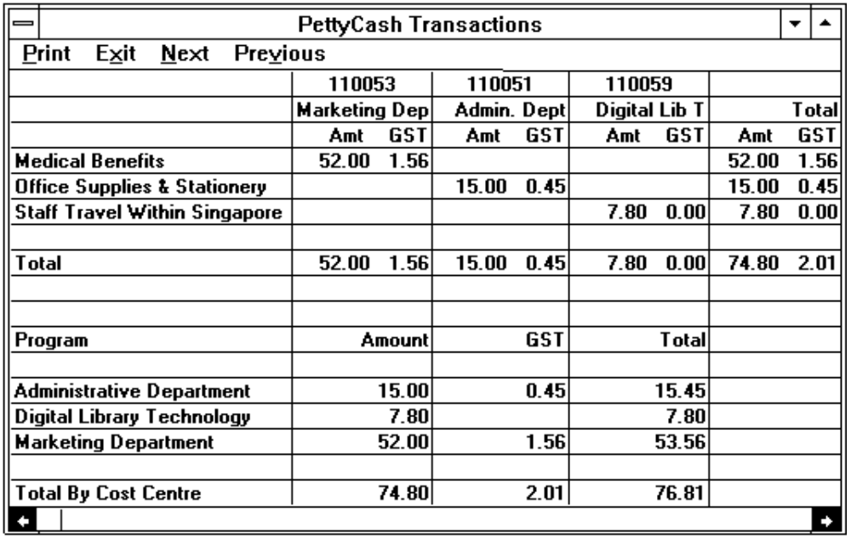
Figure 2.20.6: Dialog box for displaying petty cash transactions
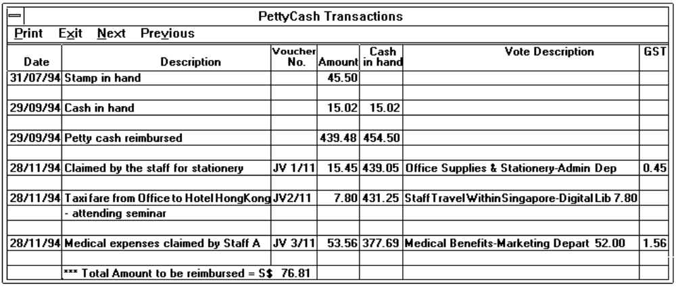
4. Choose Previous function to display the petty cash transactions (refer to Appendix A/4 & A/5) as the following dialog box (Figure 2.20.6).
5. For more information about how to print the report, please refer to Section 2.20.1 para 5 and 6.

2.20.4 Producing Claims/Expense Payment Transactions.
1. Select Claims/Expense Payment Transactions command from the Reports menu.
2. A selection dialog box (Figure 2.17.2) will be displayed for user to enter the financial year and the range of financial month. By default, they are the current system month and year.
3. The report (refer to Appendix A/6) will be shown in the dialog box (Figure 2.20.3).
4. For more information about how to print the report, please refer to Section 2.20.1 para 5 and 6.

2.20.5 Producing Claims Request Letter.
1. Select Professional Societies Subscription command from the Reports menu and then Letter to Bursar's Office command from the pull down menu.
2. For more information about how to print the report, please refer to Section 2.12.5.

2.20.6 Producing Claims for Subscription to Professional Societies Report.
1. Select Professional Societies Subscription command from the Reports menu and then Report command from the pull down menu.
2. A selection dialog box (Figure 2.20.7) will be displayed for user to enter the financial year and the range of financial month. By default, they are the current system month and year.
Figure 2.20.7: Dialog box for selecting financial month & year
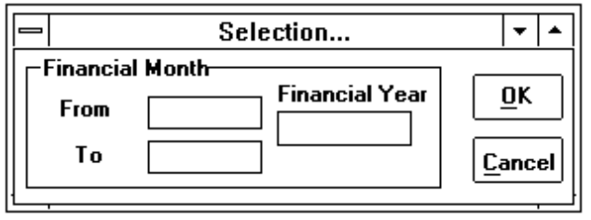
3. The report (refer to Appendix A/8) will be shown in the dialog box (Figure 2.20.3).
4. For more information about how to print the report, please refer to Section 2.20.1 para 5 and 6.
Note: This report is printed to the HP Laser printer.

2.20.7 Producing Staff Travelling Report.
1. Select Staff Travelling command from the Reports menu.
2. The following selection dialog box (Figure 2.20.8) will be displayed for user to enter the financial year and the range of financial month. By default, they are the current system month and year.
3. Choose Staff or Cost Centre option in the Sort Order by group box.
4. Choose one of the option in the Travel Type group box. By default, it is set at Locally button.
5. If the All Staff check box is unchecked (with out a 'x' in the box), then user is able to select a list of staff name from the Staff list box.
Figure 2.20.8: Dialog box for staff travel selection
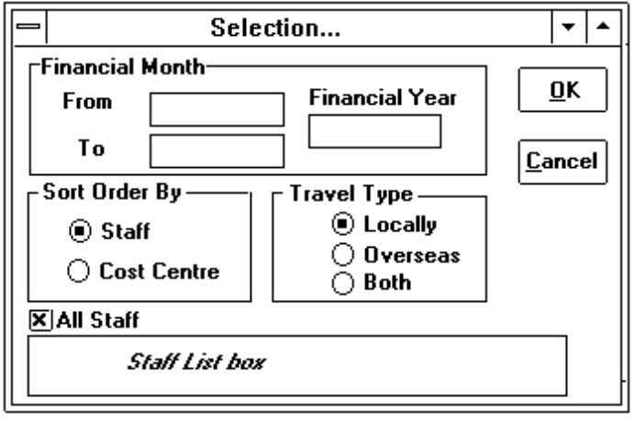
6. The report (refer to Appendix A/9) will be shown in the dialog box (Figure 2.20.3).
7. For more information about how to print the report, please refer to Section 2.20.1 para 5 and 6.

2.20.8 Producing Unsettled Payable Accounts Report.
1. Select Unsettled Payable Accounts command from the Reports menu.
2. The following dialog box (Figure 2.20.9) is displayed. Choose P/O # or Supplier option in the Sort Order by group box.
Figure 2.20.9: Dialog box for selection
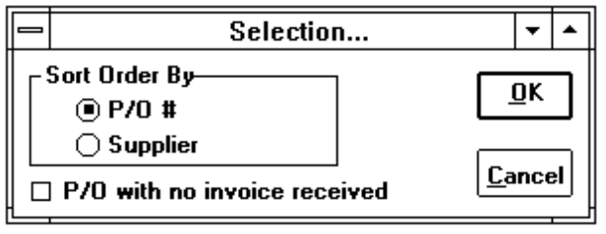
3. If the P/O with no invoice received check box is unchecked, then all the unpaid invoices will be printed. Otherwise, list of unsettled P/Os without receiving any invoice will be listed in the report.
4. The report (refer to Appendix A/10) will be shown in the dialog box (Figure 2.20.3).
5. For more information about how to print the report, please refer to Section 2.20.1 para 5 and 6.

2.20.9 Producing Vote Control Register Report.
1. Select Vote Control Register command from the Reports menu.
2. The following selection dialog box (Figure 2.20.10) will be displayed for user to enter the financial year and the range of financial month. By default, they are the current system month and year.
Figure 2.20.10 Vote Control Register Option dialog box
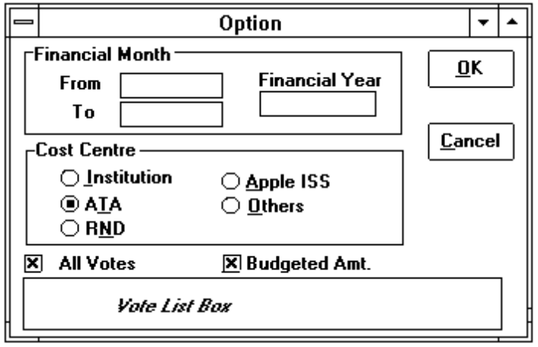
3. Choose an option from the Cost Centre group box. By default, it is ATA.
4. If the All Votes check box is unchecked, then user has to select a list of votes to be printed from the Vote list box.
5. Uncheck the Budgeted Amt check box, if user does not want the budget amount to be shown in the report.
6. The report (refer to Appendix A/11) will be shown in the dialog box (Figure 2.20.3).
7. For more information about how to print the report, please refer to Section 2.20.1 para 5 and 6.

2.20.10 Producing Total Accumulative Expenditure Report.
1. Select Total Accumulative Expenditure command from the Reports menu.
2. The following selection dialog box (Figure 2.20.11) will be displayed for user to enter the financial year and the range of financial month. By default, they are the current system month and year.
Figure 2.20.11 Option dialog box
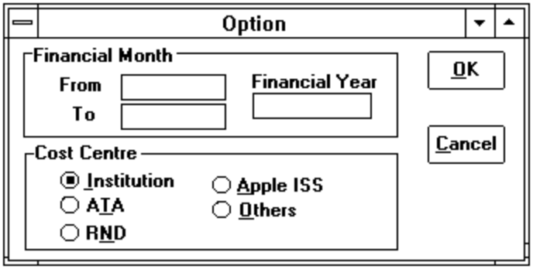
3. Choose an option from the Cost Centre group box. By default, it is Institution.
4. The report (refer to Appendix A/12) will be shown in the dialog box (Figure 2.20.3).
5. For more information about how to print the report, please refer to Section 2.20.1 para 5 and 6.

2.20.11 Producing Journal Adjustment Transactions Report.
1. Select Journal Adjustment Transactions command from the Reports menu.
2. A selection dialog box (Figure 2.20.7) will be displayed for user to enter the financial year and the range of financial month. By default, they are the current system month and year.
3. The report (refer to Appendix A/13) will be shown in the dialog box (Figure 2.20.3).
4. For more information about how to print the report, please refer to Section 2.20.1 para 5 and 6.

2.20.12 Producing Funds Transfer Transactions Report.
1. Select Funds Transfer Transactions command from the Reports menu.
2. For more information about how to print the report, please refer to Section 2.17.2 para 2 to 4.

2.20.13 Producing Cancellation of P/Os Report.
1. Select Cancellation of P/Os command from the Reports menu.
2. A selection dialog box (Figure 2.20.7) will be displayed for user to enter the financial year and the range of financial month. By default, they are the current system month and year.
3. The report (refer to Appendix A/14) will be shown in the dialog box (Figure 2.20.3).
4. For more information about how to print the report, please refer to Section 2.20.1 para 5 and 6.

2.21 Utility.
The Utility function provides facilities for users to backup the database, modify user password and access MS Windows applications : Notepad editor and Calculator.
Figure 2.21.1 Utility menu command
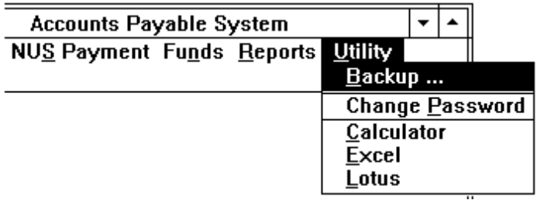

2.21.1 Performing DataBase Backup.
1. User should insert the backup tape into the tape drive of the SyBase server before performing database backup.
2. Select Backup command from Utility menu.
Figure 2.21.2: Backup message box
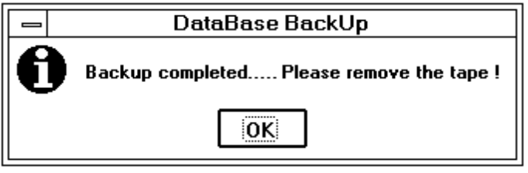
3. The above message box will be displayed if backup is successfully. Press OK button and remove the tape from the tape drive.
Note: The database will not be backed up if the following message box is displayed. Please inform the staff in charge.
Figure 2.21.3: Unsuccessful backup message box
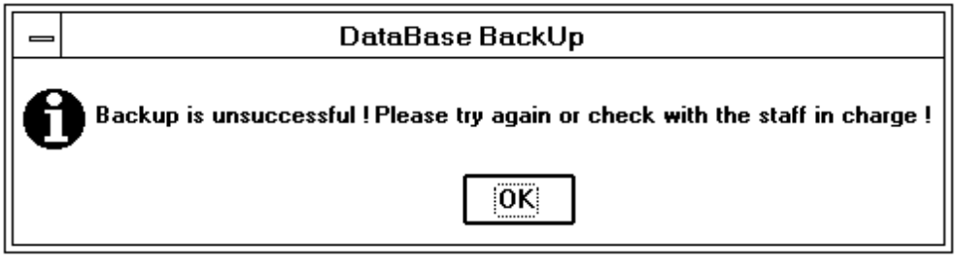

2.21.2 Modifying User's Password.
1. Select Change Password command from Utility menu.
2. The change password dialog box (Figure 2.21.4) is displayed, type in the old password and new password in the text boxes. Then re-type the new password in the Retype Password text box.
Note : The retyped password is used to double check the entered new password. They should be identical. Otherwise, the system will not accept the new password if they are different.
Figure 2.21.4: Dialog box for changing user's password
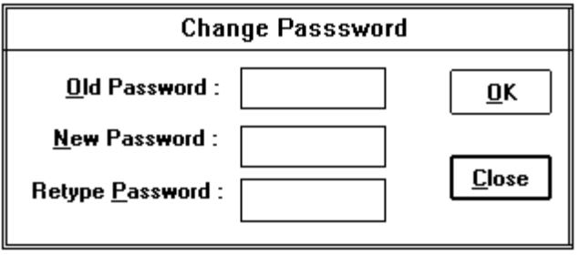
3. Choose OK button to confirm that you wish to change the password. Otherwise, choose Close button to cancel this processing.

2.21.3 Executing Calculator.
1. Select Calculator command from Utility menu.
2. The Calculator dialog box appears and the user is ready to use it.

2.21.4 Executing MS Excel.
1. Select Excel command from Utility menu.
2. The MS Excel window appears and the user is ready to use it.

2.21.5 Executing Lotus 123.
1. Select Lotus command from Utility menu.
2. Then user is ready to use the Lotus program.

3. ERROR MESSAGES & PROBLEM SOLVING.
This section will explain the problem solving for the error messages displayed on the screen.

3.1 Duplicate Records Messages.

3.1.1 Duplicate Supplier Records.
An warning message 'The supplier's name already exists ! Do you still wish to update this record ?' (see Figure 2.2.3) will be displayed during creating a supplier record that already exists. User is allowed to insert a new supplier with the same name as the existing record if the Yes button is pressed.

3.1.2 Duplicate Records For Others.
If the system does not allow an existing record to be created again, an error message 'This record already exists !' will be displayed. Press OK button to close the error message box and no record will be updated.

3.2 Invalid Date Error Messages.

3.2.1 Invalid Month.
The error message 'The month should be between 1 and 12 !' will be displayed when the month of a date is entered incorrectly. Press OK button and re-enter the date again.

3.2.2 Invalid Day.
The error message 'There is only nn days in that month !' will be displayed when the day of a date is entered incorrectly. Press OK button and re-enter the date again.
Note: nn is the number of the days in a month.

3.3 Insufficient funds available.
A warning message 'Insufficient funds available ! The available amount is xxxxx' will be displayed when a vote is committed. Press OK button and the vote commitment is still accepted. However, user needs to verify with the senior staff about the funds of the committed vote.

3.4 Total Committed Amount Error.
An error message 'The total committed amount is not equal to the entered committed amount !' will be displayed when the total commitment of the committed votes (computed by the system) is different from the entered committed amount (ie. P/O amount, invoice amount & etc.). Press OK button and check the entries.

3.5 Total Amount of Funds Cancelled Error.
An error message 'Total funds cancelled is more than the entered cancelled amount !' will be displayed when the total cancelled amount of the committed votes (computed by the system) is different from the amount to be cancelled (entered by the user). Press OK button and check the entries

3.6 Petty Cash Balance Error.
An error message 'The Petty cash balance is more than $500.00 !' will be displayed when user tries to update the reimbursed petty cash amount. Press OK button and check the reimbursed amount whether it was entered incorrectly. If it is not, please inform the staff-in-charge.

3.7 Error Message for NUS Cash Payment.

3.7.1 Cash Payment Error.
An error message 'Please enter the amount again ! It should be xxx !' will be displayed when the entered NUS cash payment amount is more than the invoice amount (in S$). Press OK button and re-enter the payment amount again.

3.7.2 Invalid Payment Date.
Normally, the payment date is entered as month and year (ie 0593 for May 93) only. If the date is not entered as the format given above, an error message 'Please enter the payment date as mmyy ie 0593 !' will be displayed. Press OK button and re-enter the date again.
Note: mm is the month and yy is the year.

3.8 Funds Transfer Error Messages.
There are two types of error messages for the processing of funds transfer.

3.8.1 The balance after transfer is less than 0.
The above error message is displayed, when user tries to transfer a certain amount from the vote and the balance amount after transfer is less than zero. Press OK button and check the entries.

3.8.2 The amount transferred is more than 20 %.
If the transferred amount of a vote is more than 20 % of the budget amount of the cost centre that the vote belonged to, the above error message will be displayed. Press OK button and check the entries.

3.9 Zero Commitment.
When user tries to enter a P/O with zero P/O amount into the system, an error message 'The Commitment is zero ! Do you still wish to save it ?' will be displayed. If it is a cancelled P/O to be captured in the system, then press Yes button to accept it. Otherwise, just press No button to ignore it.

3.10 Invalid Financial Year and Month.

3.10.1 Invalid Financial Year.
The error message 'The year should be greater than 0 !' will be displayed when the entered year is less than zero. Press OK button and re-enter the year again.

3.10.2 Invalid Financial Month.
The error message 'The entered month should be between 1 and 12 !' will be displayed when the month is entered incorrectly. Press OK button and re-enter the month again.

3.11 Invalid numeric data.
If a numeric entry is entered incorrectly, an error message 'The entered data is not numeric !' will be displayed. Press OK button and re-enter the number again.

3.12 Invalid Currency Exchange Rate.
If the entered exchange rate is less than zero, an error message 'The exchange rate should be greater than 0 !' will be displayed. Press OK button and re-enter the rate again.

3.13 Invalid S$ Amount.
If the difference between an entered S$ equivalent amount and the S$ amount generated by the system is more than 0.9, the error message 'S$ amount is incorrect !' will be displayed. Check the exchange rate and the entered S$ amount.

3.14 Applications Execution Error Messages.

3.14.1 Not Enough memory to run the application.
When the message 'Not Enough memory to run the application !' is displayed, check the applications are running at that moment and close some of them if it is possible.

3.14.2 Unable to run the application.
Please inform the staff-in-charge when the message 'Unable to run the application !' is displayed.

3.14.3 EXE file does not exist.
Please inform the staff-in-charge when the message 'EXE file does not exist !' is displayed.

Appendix A SAMPLES OF REPORTS.
The purpose of this appendix is to show the samples of the printed reports that are produced by the system. They are as follows :
1. | Purchase Order Transactions
2. | Received Invoice Transactions
3. | Petty Cash Transactions
4. | Claims/Expense Payment Transactions
5. | Claims Request Letter
6. | Claims for Subscription to Professional Societies Report
7. | Staff Travelling Report
8. | Unsettled Payable Accounts
9. | Vote Control Register
10. | Total Accumulative Expenditure
11. | Journal Adjustment Transactions
12. | Cancellation of P/Os Report
13. | Currency Exchange Rate
14. | Budgeted Accounts
15. | Funds Transfer Transactions

Financial Month : 05 - 06 Purchase Order Transactions Page 1
Date 16/09/94
Time 09:54:33
P/O P/O & <-------------------Invoice-------------------> Pre-
Date PRF No. Supplier & Description Amount No. & Ref. Date Amount Pymt
04/05/94 230001 ESSEX ELECTRIC PTE LD S$ 1,785.00 8721851 03/06/94 S$ 892.50 N
110025 12 units of the calculator for the Admin 1
Dept and Real-Time Processing Dept 91154274 08/08/94 S$ 595.00
4
04/05/94 230002 OAKWELL ENGINEERING (S) PTE LD S$ 2,234.00 I-7891224 25/06/94 S$ 2,234.00 N
110027 Maintenance of Central Air-conditional 2
24/06/94 230003 BETALAND ENTERPRISES COMPANY STG 4,258.00 N
110028 1 set of Education software and manual S$ 12,195.76
27/06/94 230005 OAKWELL ENGINEERING (S) PTE LD S$ 12,743.00 N
110030 Computer annual maintenance charges
Total S$ 28,957.76
********** End of Report **********
Financial Month : 05 - 07 Received Invoice Transactions Page 1
Date 20/09/94
Time 16:55:27
<-------Invoice--------> <-----P/O-----> Invoice Date snet Payment
No. Date Ref. No. No. & Date Supplier & Description Amount S$ Amount to Bursar Date
147513288 20/05/94 13 METIER MANAGEMENT CO PTE S$ 3,250.00 3,250.00 22/08/94 09/94
Medical charges received from the clinic
85427913 25/06/94 11 THE NEAT CORPORATION (SEA) PTE LTD S$ 3,250.00 3,250.00 28/06/94
Local mail delivery services
8721851 03/06/94 1 PO-230001 ESSEX ELECTRIC PTE LTD S$ 892.50 892.50 05/06/94 06/94
04/05/94 Only 6 units of calculators were received
2546712 30/07/94 5 PO-230005 OAKWELL ENGINEERING (S) PTE LD S$ 3,185.00 3,185.00 12/08/94
27/06/94 Computer maintenance charges is
partially invoiced
Total S$ 10,577.50
********** End of Report **********
Financial Month : 11 Petty Cash Transactions Page 1
Date 28/11/94
Time 13:54:56
Voucher Cash in
Date Description No. Amount hand <----------------------------------------Vote----------------------------------------> GST
31/07/94 Stamp in hand 45.50
29/09/94 Cash in hand 15.02 15.02
29/09/94 Petty cash reimbursed 439.48 454.50
28/11/94 Calimed by the staff for stationery JV 1/11 15.45 439.05 Office Supplies & Stationery-Administrative Dept 15.00 0.45
28/11/94 Taxi fare from Office to Hotel HongKong JV2/11 7.80 431.25 Staff Travel Within Singapore-Digital Library Te 7.80
- attending seminar
28/11/94 Medical expenses claimed by Staff A JV 3/11 53.56 377.69 Medical Benefits-MArketing Department 52.00 1.56
*** Total Amount to be reimbursed = S$ 76.81
Summary :
--------------------
<---------------------Vote Description-----------------> Marketing Dep Admin. Dept Digital Lib T Total
Amt Gst Amt GST Amt GST Amt GST
Medical Benefits 52.00 1.56 52.00 1.56
Office Supplies & Stationery 15.00 0.45 15.00 0.45
Staff Travel Within Singapore 7.80 0.00 7.80 0.00
------------------------------------------------------------------------------------
Total 52.00 1.56 15.00 0.45 7.80 0.00 74.80 2.01
===============================================
<----------------------Cost Centre----------------------> Amount GST Total
Administrative Department 15.00 0.45 15.45
Digital Librasry Technology 7.80 7.80
Marketing Department 52.00 1.56 53.56
--------------------------------------------------------
Total 74.80 2.01 76.81
===============================
********** End of Report **********
Financial Month : 08 - 09 Claims / Expens Payment Transactions Page 1
Date 03/10/94
Time 09:02:10
Reference <----------------------Commitment-----------------------> Cash Pymt
Date & Claim No. Description Amount Vote Description Amount Date
05/08/94 000004 Study allowance paid to the staff S$ 402.00 Staff Travel Outside Singapore 163.00 08/94
-information & Technical Technology
Staff Tracel Outside Singapore 239.00
-Multi Distribution Computing
10/08/94 000005 Overseas mail services S$ 182.00 Postage 58.00 08/94
-Multi Distribution Computing
Postage 124.00
-Network & Data Communication
11/08/94 000001 CCS and WWNS subscription claimed by S$ 125.00 Staff Travel Wihtin Singapore 62.50 08/94
Melvin Yak Hock Hwa -Chinese Software Development
Staff Travel Wihtin Singapore 62.50
-Digital Library Technology
-Software Development Dept
17/09/94 000002 IEC and WWNS subscription for Wan Lee Li S$ 125.00 Staff Travel Wihtin Singapore 125.00 09/94
-System Planning Department
27/09/94 000003 BIA subscription for S K Gurupeakash S$ 109.36 Staff Travel Wihtin Singapore 54.68 09/94
-information & Technical Technology
Staff Travel Wihtin Singapore 54.68
-System Planning Department
Total S$ 943.36
********** End of Report **********
1 October 94
Miss Particia Choo Our Reference : 000001
Bursar's Office
National University of Singapore
REIMBURSEMENT
Please reimburse the following in cash being claims for subscription to Professional
Societies. Receipts are attached.
Name Society Amount Vote
Melvin Yak Hock Hwa CCS S$ 55.00 Staff Travel Within Singapore-
Chinese Software Development
Staff Travel Within Singapore-
Digital Library Technology
Melvin Yak Hock Hwa WWNS S$ 70.00 Staff Travel Within Singapore-
Chinese Software Development
Staff Travel Within Singapore-
Digital Library Technology
Lian Wee Li (Miss)
Manager, Administration
for Director
Financial Month : 08 - 09 Claims for Subscription to Professional Societies Page 1
Date 30/09/94
Time 12:50:25
Professional Period of Subscription Amount
Name Society Membership Amount Claimed Date
Melvin Yak Hock Hwa CCS 1994 S$ 55.00 S$ 55.00 11/08/94
Melvin Yak Hock Hwa WWNS 1994 S$ 80.00 S$ 70.00 11/08/94
S K Guruprakash BIA 1994 US$ 70.00 S$ 109.36 27/08/94
Wan Lee Lian WWNS 1994 S$ 75.00 S$ 40.19 17/09/94
Wan Lee Lian IEC 1994 US$ 55.00 S$ 84.41 17/09/94
------------------
Total S$ 359.36
============
Financial Month : 08 Staff Travelling Report Page 1
Date 01/10/94
Time 11:09:36
Date / Estimated <---------------------Actual----------------------> Total
<----------------Staff---------------> Ref. No. <-------------Event------------> Expenses Air Fare Registration Advance Claims Amt Paid
Administration Department
Vote : Staff Travel Within Singapore
Linda Koo Mei Hian 10/08/94 8-12 December 94 1,800.00 0.00 S$ 0.00 0.00 0.00 0.00
000001 Computer Security Course
Computer Training Centre
Singapore
Total 1,800.00 0.00
System Planning Department
Vote : Staff Travel Outside Singapore
S K Guruprakash 12/08/94 10-12 Oct 94 2,175.00 0.00 S$ 0.00 0.00 0.00 0.00
000002 Open Client/Server Computing
Tasksimaya Hotel
Kyoto, Japan
Wan Lee Lian 12/08/94 25-27 Nov 94 4,500.00 0.00 S$ 0.00 0.00 0.00 0.00
000003 The Operating System of the Future
Hotel Holiday Inns
San Franciso, USa
Total 6,675.00 0.00
********** End of Report **********
Financial Month : 05 - 08 Unsettled Payable Accounts Page 1
Date 01/10/94
Time 11:37:00
<------------P/O------------> <---------Invoice---------> Date sent
No. Date Supplier & Description Amount S$ Amount No. Date to Bursar
ALTEC DIGITAL SYSTEMS PTE LTD S$ 1,125.00 1,125.00 4127236 20/05/94 22/05/94
Binding the teaching materials
METIER MANAGEMENT CO LTD S$ 3,528.00 3,528.00 147513288 18/08/94 22/08/94
Medical charges received from the clinic
partially invoices
P 230005 27/06/94 OAKWELL ENGINEERING (S) PTE LTD S$ 4,140.80 4,140.80 2546712 30/07/94 12/08/94
PRF 110030 Computer maintenance charges is
partially invoices
SOYUZ TRADING SDN BHD S$ 1,500.00 1,500.00 B 794112 30/05/94 02/06/94
Holiday chalets for the staff member
THE NEAT CORPORATION (SEA) PTE LTD S$ 980.00 980.00 85427913 25/08/94 28/06/94
Local mail delivery services
P 230004 25/06/94 vitomatic marketing & consultants co. S$ 581.00 904.04 I-7891224 29/07/94 31/07/94
PRF 110029 A set of Education tape
Total 12,177.84
********** End of Report **********
Financial Month : 05 - 08 Vote Control Register - ATA Page 1
Date 01/10/94
Time 12:04:48
Vote : 00002 Office Supplier & Stationery Budget Amount : S$ 39,370.00 Balance B/F : S$ 39,370.00
Funds
Ref. No. Commitment Balance <------Invoice-------> Bal to Surpulus Date sent Pymt
/PO. No. Date Supplier & Description Program Cahrageable Amount Available Date/No. Amount be Paid (Deficit) to Bursar Date
230001 04/05/94 ESSEX ELECTRIC PTE LTD Admin. Dept. 743.75 38626.25 03/06/94 446.25 05/06/94 06/94
12 units of the calculator for the Admin 8721851
Dept and Real-Time Processing Dept 08/08/94 297.50 12/08/94 08/94
91154274
230001 04/05/94 ESSEX ELECTRIC PTE LTD Real-Time Processing 743.75 37882.50 03/06/94 446.25 05/06/94 06/94
12 units of the calculator for the Admin 8721851
Dept and Real-Time Processing Dept 08/08/94 297.50 12/08/94 08/94
91154274
000002 10/07/94 Transfer funds from Staff Travel within Digital Lib Technology -8500.00 46382.50 07/94
(T ) Singapore to Office Supplies & Statione
VB 001133 17/08/94 Paid to Linda Koo Mei Hain for buying Admin. Dept 15.00 46367.50
(PC) the Business Directory
Total -6997.50 46367.50 1487.50 892.50 595.00
********** End of Report **********
Financial Month : 06 - 09 Total Accumulative Expenditure As At 30/09/94 Page 1
(ATA) Date 01/10/94
Time 12:00:38
110051 110052 110053 110054 Total Budgeted
Vote Description Admin Dept System Planning Marketing Dept Software Dev. D Expenditure Amount Balance
Equipment Maintenance 0.00 4,205.19 -3,441.50 763.69 29,700.00 28,936.31
Equipment (Replacement) 7,600.00 7,600.00 35,000.00 27,400.00
Medical Benefits 882.00 0.00 0.00 882.00 52,500.00 51,618.00
Office Supplies & Stattionery 758.75 0.00 0.00 758.75 9,450.00 8,691.25
Postage 5.25 0.00 5.25 10.50 300.00 289.50
Software Development Department 20,185.00 20,185.00 150,000.00 129,815.00
Staff Travel Outside Singapore 0.00 6,675.00 3,200.00 9,875.00 115,000.00 105,125.00
Staff Travel Within Singapore 1,812.00 179.68 1,072.00 3,063.68 75,000.00 71,936.32
Staff Welfare & Recreation 375.00 0.00 574.00 949.00 3,700.00 2,751
Teaching Materials 1,712.04 1,712.04 26,000.00 24,287.96
Telephone 0.00 0.00 2,775.97 2,775.97 8,000.00 5,224.03
Total OOE 3,833.00 20,371.91 4,185.72 20,185.00 48,575.63 504,650.00 456,074.37
********** End of Report **********
Financial Month : 10 - 10 Journal Adjustment Transactions Page 1
Date 01/10/94
Time 11:04:18
Date Ref. No. S/No. Cost Centre / Vote Description Payment Receipt Remarks
14/10/94 J/V/10/1 1 Administrative Department 125.00 Calculator purchased by the clerical staff
Office Supplies & Stationery
14/10/94 J/V/10/1 2 Administrative Department 12.00 over payment and refunded by the clinic
Medical Benefits
14/10/94 J/V/10/1 3 Information & Technical Technology 15.00 20.00 $15 claimed by the office clerk and
Postage reimbursed $20
14/10/94 J/V/10/2 1 Chinese Software Department 250.00 Computer Form printed
Office Supplies & Stationery
14/10/94 J/V/10/2 2 Information & Technical Technology 124.00 Lunch for VIP
Other expenses
Total 389.00 32.00
********** End of Report **********
Financial Month : 05 - 06 Cancellation of POs Transactions Page 1
Date 01/10/94
Time 12:00:38
P/O & <-------------Cancellation of Funds Committed-------------> Date
P/O Date PRF No. Supplier & Description P/O Amount Cancelled Vote Description Amount Cancelled
04/05/94 230001 ESSEX ELECTRIC PTE LTD S$ 1,7850.00 297.50 Office Supplies & Stationery-Administrative Depart 148.75 24/09/94
110025 Supplier is unable to deliver another 2 Office Supplies & Stationery-Rel-Time Processing 148.75 CL-000001
calculators that stock are unavailable
24/06/94 230003 BETALAND ENTERCOMPANY STG 4,258.00 4,258.00 Teaching Materials-System Planning Department 12,195.76 23/09/94
110028 The stock is unavailable currently S$ 12,195.76 12,195.76 CL-000002
Total S$ 12,493.26
********** End of Report **********
Currency Exchange Rate Page 1
Date 13/09/94
Time 17:19:00
Currency Code Exchange Rate Remarks
A$ 1.118400 user1 01/09/94
DM$ 0.970814 user1 01/09/94
HK$ 0.191363 user1 01/09/94
M$ 0.581218 user1 10/09/94
S$ 1.000000 user1 01/09/94
STG 2.335500 user1 01/09/94
US$ 1.505210 user2 15/09/94
YEN 0.015238 user1 01/09/94
********** End of Report **********
Budgeted Accounts For the Financial Year 94 Page 1
Date 01/10/94
Time 12:00:38
Administrative Chinese Soft Digital Lib Inform & T Marketing Distribution Network & D
Vote Description 110051 110057 110059 110056 110053 110060 110055 Total
Equipment Maintenance 1,500.00 20,000.00 27,000.00 18,000.00 1,200.00 15,000.00 35,000.00 117,700.00
Medical Benefits 25,000.00 18,000.00 32,000.00 25,000.00 12,500.00 28,000.00 30,000.00 170,500.00
Office Supplies & Stationery 4,200.00 2,120.00 7,100.00 3,100.00 3,150.00 6,150.00 5,200.00 31,020.00
Postage 100.00 100.00 100.00 100.00 100.00 100.00 100.00 700.00
Publicity 2,500.00 2,500.00 2,200.00 3,500.00 3,000.00 2,000.00 15,700.00
Staff Travel Outside Singapore 30,000.00 15,000.00 32,000.00 25,000.00 40,000.00 10,000.00 30,000.00 182,000.00
Staff Travel Within Singapore 15,000.00 18,000.00 20,000.00 20,000.00 35,000.00 20,000.00 30,000.00 158,00.00
Staff Welfare & Recreation 1,200.00 750.00 2,000.00 1,350.00 1,500.00 1,000.00 800.00 8,600.00
Telephone 2,500.00 2,000.00 2,500.00 2,000.00 3,000.00 3,000.00 5,500.00 20,500.00
Utilities 6,500.00 3,550.00 5,000.00 4,000.00 3,500.00 6,000.00 6,500.00 35,050.00
Total 86,000.00 82,020.00 130,200.00 100,750.00 103,450.00 92,250.00 145,100.00 739,770.00
********** End of Report **********
Financial Month : 07 - 07 Funds Transfer Transactions Page 1
Date 30/10/94
Time 15:27:32
<-Amount Transferred->
Date Reference No. From TO <--------Funds Transferred From Vote / To Vote--------> <---------------------Remarks--------------------->
10/07/94 000001 1,500.00 Software Developmet Department Transfer funds from Software Development
1,500.00 Staff Welfare & Recreation - Chinese Software Dev. to Staff welfare of Chinese Software Develop
10/07/94 000002 8,500.00 Staff Travel Within Singapore - Digital Library Technolo Transfer funds from Staff Travel within Singapore
5,500.00 Office Supplies & Stationery - Digital Library Technolo to Office Supplies & Stationery & other expenses
3,000.00 Other Expenses - Digital Library Technolo
15/07/94 000003 3,200.00 Staff Travel Outside Singapore - Marketing Department Transfer funds from Marketing Dept to Network &
1,300.00 Equipment Maintenance - Network & Data Comm. Data Communication,Admin Dept.and Real-Time
1,100.00 Equipment Maintenance - Real-Time Processing
800.00 Telephone- Administrative Department
********** End of Report **********

Approval Record ISS/Forms/Approval

Project Name FCS Accounts Payable Project
Document Ref ISS/FCS2/TU.1/1
Approved by | Date
Authorised by | Date
The document authorisation appears on the title page.
The structure of the publication is logical.
The distribution list is correct.
The title page is signed.
Calculations appear reasonable, are neatly presented and have been checked.
Theory and formulae are correct and properly applied.
Illustrations are relevant, readable and logically placed.
There are no typographical errors.
Units are consistent throughout.
The security classification is correct.
There are no obvious omissions.
The document complies with the Client's requirements, however specified.
Responsibility is accepted for all opinions, conclusions and recommendations.
The document does not run counter to company policy.

